CSS ISLAMIC STUDIES · T6QA
بِسۡمِ ٱللَّهِ ٱلرَّحۡمَٰنِ ٱلرَّحِيمِ
Topic VI — Islam, the West and the Muslim World
The Question Answers · Every past-paper question of Topic 6, 2015–2026, answered as a model
Nine model answers — the Ummah, individuality, the challenges of the Muslim world, co-existence, Islamophobia, the reconstruction of Pakistani society, Muslim views of the West, the Two-Nation Theory, and the West's influence on Muslim societies. Each begins with an answer map that states exactly what the question asks.
Edition of September 2026 · covers the papers of 2015–2026 · written for CSS 2027 and after
Contents
HOW TO BUILD THE CONTENTS
The Contents below is left empty on purpose. In Microsoft Word, right-click anywhere on the grey line below and choose Update Field → Update entire table → OK. The full table of contents with page numbers will appear.
On a Mac: right-click (or Control-click) the line → Update Field. If you edit the notes later, repeat this step to refresh the page numbers. You can also press Ctrl + A then F9 (Windows) to update every field in the document at once.

How to Use These Answers 6
What is in this document 6
How every answer is built 6
Answer 1 · The Muslim Ummah: Concept, Structure and Revival (CSS 2015) 7
Decoding the question 7
The model answer 8
(1) Introduction 8
(2) The concept of the Ummah 8
(3) The structure of the Ummah 9
(4) Why the Ummah declined 10
(5) Suggestions for revival 10
(5a) The Ummah acting as one body — examples 11
(5b) The obstacles to revival — and how to overcome them 12
(5c) Pakistan's role 12
(6) Conclusion 12
Why this answer scores 12
Answer 2 · Islamic Ideology and Modern Western Thought on Individuality (CSS 2015) 14
Decoding the question 14
The model answer 14
(1) Introduction 14
(2) Individuality and individualism 15
(3) Modern Western thought 15
(4) Present trends of individuality in the West 15
(5) Islamic ideology of the individual 15
(6) The comparison 16
(7) Iqbal's synthesis — Khudi and Bekhudi 17
(8) The trend among Muslims 17
(8a) The evidence of consequences 17
(8b) What Islam appreciates in Western individuality 17
(8c) The trend among Pakistani youth 17
(9) Conclusion 18
Why this answer scores 18
Answer 3 · Contemporary Challenges of the Muslim World and Their Solutions (CSS 2016) 19
Decoding the question 19
The model answer 20
(1) Introduction 20
(2) The contemporary challenges 20
(3) The solutions in the light of the Quran and Sunnah 21
(3a) Two case notes 25
(3b) The role of the OIC and of Pakistan 25
(4) Conclusion 26
Why this answer scores 26
Answer 4 · Islam's Teachings on Co-existence in a Multi-faith Society (CSS 2021) 27
Decoding the question 27
The model answer 27
(1) Introduction 27
(2) The Quranic principles 28
(3) The Prophetic model 30
(4) The historical record 31
(5) Modern Muslim declarations 31
(6) Co-existence in Pakistan 31
(7) Muslims as minorities 31
(8) The limit — co-existence is not syncretism 31
(8a) The rights of non-Muslims in an Islamic state — the list 31
(8b) The scholars 32
(9) Conclusion 32
Why this answer scores 32
Answer 5 · Islamophobia Is a Sign of Extremism: Remedies (CSS 2021) 33
Decoding the question 33
The model answer 33
(1) Introduction 33
(2) The forms of Islamophobia 34
(3) The causes 34
(4) Why Islamophobia is a sign of extremism 34
(5) Suggestions for its remedy 36
(5a) Pakistan's role against Islamophobia 37
(5b) The role of the Muslim diaspora 37
(6) Conclusion 37
Why this answer scores 38
Answer 6 · The Reconstruction of Pakistani Society in the Light of Islamic Teachings (CSS 2022) 39
Decoding the question 39
The model answer 39
(1) Introduction 39
(2) The constitutional foundation 40
(3) Why reconstruction is needed 40
(4) Reconstruction area by area 40
(5) The model — the society of Madinah 44
(6) A staged roadmap 44
(5a) The roles of the key actors 44
(5b) The vision of Iqbal and the Quaid 44
(7) Conclusion 45
Why this answer scores 45
Answer 7 · Muslim Views of Western Civilization — Identified and Analysed (CSS 2025) 46
Decoding the question 46
The model answer 46
(1) Introduction 46
(2) View 1 — Total rejection 47
(3) View 2 — Total acceptance (Westernisation) 47
(4) View 3 — Synthesis (reform) 48
(5) View 4 — Critical engagement 48
(6) View 5 — Dialogue and co-existence 48
(7) View 6 — The conspiracy view 49
(8) The comparative analysis 49
(9) The views in Pakistan today 50
(10) The balanced Islamic position 50
(10a) Why each view arose — the historical context 50
(10b) Which view is growing 50
(11) Conclusion 51
Why this answer scores 51
Answer 8 · The Two-Nation Theory: Justification and Demands, in the Light of Indian and Kashmiri Muslims (CSS 2026) 52
Decoding the question 52
The model answer 53
(1) Introduction 53
(2) The Islamic basis 53
(3) The historical development 54
(4) The justification 54
(5) The plight of Indian Muslims — the theory confirmed 54
(6) The plight of Kashmiri Muslims 55
(7) The demands of the Two-Nation Theory today 55
(8) The objections answered 56
(8a) Pakistan's diplomatic record on Kashmir 56
(8b) What the leaders said about the ideology of Pakistan 56
(9) Conclusion 57
Why this answer scores 57
Answer 9 · The West's Influence on Islamic Civilization and Measures to Protect Muslim Societies (CSS 2026) 58
Decoding the question 58
The model answer 58
(1) Introduction 58
(2) How the West influenced Islamic civilization — the phases 59
(3) The positive influences 59
(4) The negative influences 60
(5) The measures to protect Muslim societies 61
(5a) The historical Muslim responses 62
(5b) Western influence in Pakistan — examples 62
(6) Conclusion 63
Why this answer scores 63

How to Use These Answers

What is in this document
# | Paper | Question (short) | Answer
1 | 2015 Q2 | Concept and structure of the Ummah; suggestions for its revival | Answer 1
2 | 2015 Q9 | Islamic ideology and modern Western thought on individuality | Answer 2
3 | 2016 Q8 | Contemporary challenges of the Muslim world and solutions from the Quran and Sunnah | Answer 3
4 | 2021 Q4 | Islam's teachings on co-existence in a multi-faith society | Answer 4
5 | 2021 Q5 | Islamophobia as a sign of extremism; its remedy | Answer 5
6 | 2022 Q7 | Reconstruction of Pakistani society in the light of Islam | Answer 6
7 | 2025 Q8 | Views about Western civilization in Muslim circles — identified and analysed | Answer 7
8 | 2026 Q3 | Justification and demands of the Two-Nation Theory, in the light of Indian and Kashmiri Muslims | Answer 8
9 | 2026 Q4 | The West's influence on Islamic civilization; measures to protect Muslim societies | Answer 9

How every answer is built
1. The question, exactly as set.
2. The answer map — the centre states exactly what the question asks; every box is a heading, and every point is a complete idea.
3. Decoding the question.
4. The model answer — headings from the question's words; evidence Quran → Hadith → history → scholars and data; figures; Pakistan; a conclusion with a verse or hadith.
5. Why this answer scores.
TRAP · FACTS, BALANCE AND DATES
These questions reward dates, organisations, resolutions and numbers, stated calmly. Learn the tables; update the numbers you remember with the latest you read before the paper.

Answer 1 · The Muslim Ummah: Concept, Structure and Revival (CSS 2015)
THE QUESTION · CSS 2015 · Q2 · 16 marks
Explain the concept and structure of the Muslim Ummah and give suggestions for its revival.

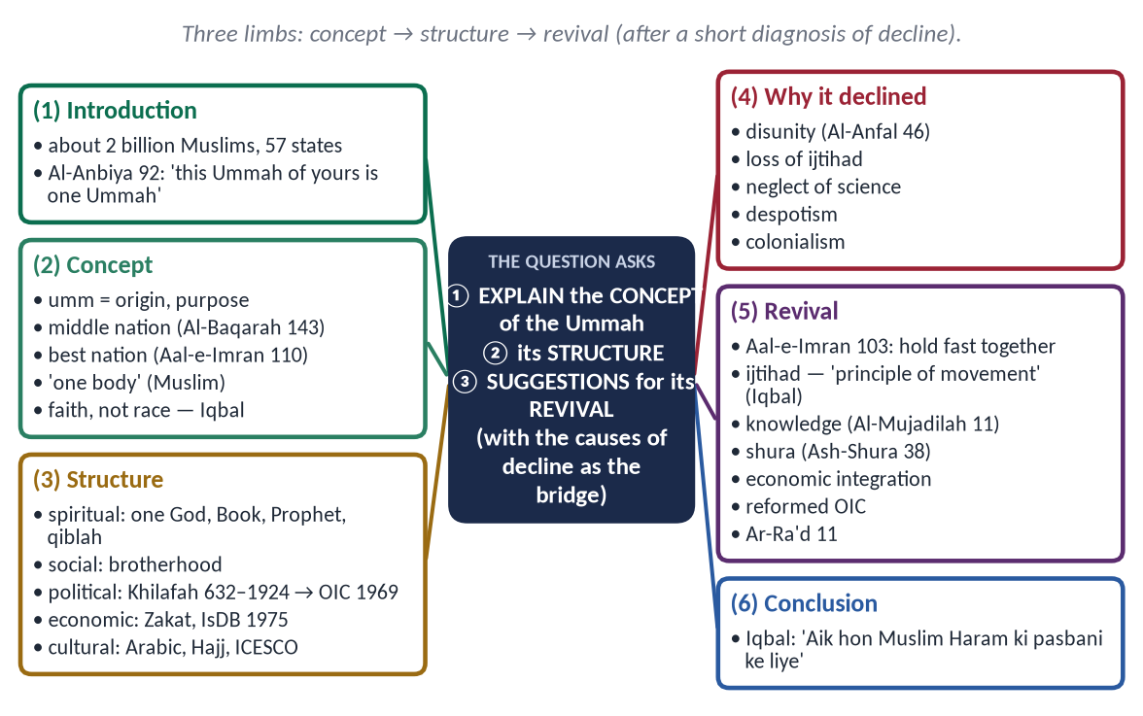
Figure 1 · The answer map: every branch is one numbered heading of the model answer below.

Decoding the question
- 'Concept' — what the Ummah is, from the Quran and Sunnah; how it differs from a nation-state.
- 'Structure' — how it is organised: spiritual, social, political, economic and cultural.
- 'Suggestions for its revival' — a practical plan; a short diagnosis of decline makes the suggestions logical.
- 16 marks — keep it tight.

The model answer

(1) Introduction
✦ QURAN
﴿إِنَّ هَٰذِهِۦٓ أُمَّتُكُمۡ أُمَّةٗ وَٰحِدَةٗ وَأَنَا۠ رَبُّكُمۡ فَٱعۡبُدُونِ﴾
“Indeed this, your religion, is one religion, and I am your Lord, so worship Me.” (Al-Anbiya, Quran)
➜ 'Indeed, this Ummah of yours is one Ummah, and I am your Lord, so worship Me.'

About two billion Muslims — a quarter of humanity — live in 57 states and as minorities across the world. The Quran calls them one Ummah. Yet today they are divided, weak and often oppressed. Understanding the concept and structure of the Ummah is the first step to its revival.

(2) The concept of the Ummah

(i) The meaning
Ummah (أُمَّة) comes from umm — mother, origin, purpose. It is a community united by a common faith and purpose, not by race, language or territory.

(ii) Its qualities in the Quran
✦ QURAN
﴿وَكَذَٰلِكَ جَعَلۡنَٰكُمۡ أُمَّةٗ وَسَطٗا لِّتَكُونُواْ شُهَدَآءَ عَلَى ٱلنَّاسِ وَيَكُونَ ٱلرَّسُولُ عَلَيۡكُمۡ شَهِيدٗاۗ …﴾
“And thus We have made you a middle (just) nation, that you may be witnesses over mankind and the Messenger a witness over you.” (Al-Baqarah, Quran)
➜ 'We have made you a middle nation, that you may be witnesses over mankind.'

✦ QURAN
﴿كُنتُمۡ خَيۡرَ أُمَّةٍ أُخۡرِجَتۡ لِلنَّاسِ تَأۡمُرُونَ بِٱلۡمَعۡرُوفِ وَتَنۡهَوۡنَ عَنِ ٱلۡمُنكَرِ وَتُؤۡمِنُونَ بِٱللَّهِۗ …﴾
“You are the best nation brought forth for mankind: you enjoin what is right, forbid what is wrong, and believe in Allah.” (Aal-e-Imran, Quran)
➜ 'You are the best nation brought forth for mankind: you enjoin right, forbid wrong and believe in Allah.'

(iii) Brotherhood — its bond
✦ HADITH
مَثَلُ الْمُؤْمِنِينَ فِي تَوَادِّهِمْ وَتَرَاحُمِهِمْ وَتَعَاطُفِهِمْ مَثَلُ الْجَسَدِ، إِذَا اشْتَكَى مِنْهُ عُضْوٌ تَدَاعَى لَهُ سَائِرُ الْجَسَدِ بِالسَّهَرِ وَالْحُمَّى
“The believers, in their love, mercy and kindness, are like one body: when one limb suffers, the whole body responds with sleeplessness and fever.” (Muslim)

(iv) Faith, not race
✦ SCHOLARLY VIEW
Allama Muhammad Iqbal · Bang-e-Dra
'Apni millat par qiyas aqwam-e-maghrib se na kar / Khas hai tarkib mein qaum-e-Rasool-e-Hashmi' — do not compare your nation with the nations of the West; the nation of the Prophet ﷺ is unique in its composition.
➜ The Ummah is ideological.

(3) The structure of the Ummah
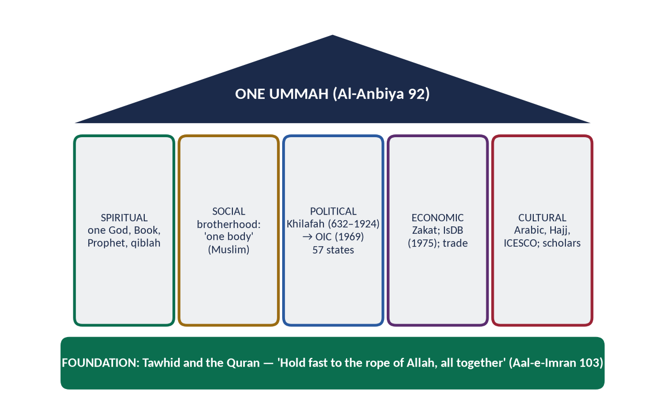
Figure 2 · The structure of the Ummah.
- Spiritual: one God, one Book, one Prophet ﷺ, one qiblah; the annual Hajj as the Ummah's assembly.
- Social: brotherhood; rights of Muslims on one another; the mosque as community centre.
- Political: the Khilafah from 632 to 1924; today 57 states cooperating through the OIC (founded Rabat, 1969, after the arson at Al-Aqsa; secretariat Jeddah).
- Economic: Zakat and waqf within societies; the Islamic Development Bank (1975) between states.
- Cultural: Arabic as the language of worship; universities such as Al-Azhar; ICESCO.

(4) Why the Ummah declined
✦ QURAN
﴿وَأَطِيعُواْ ٱللَّهَ وَرَسُولَهُۥ وَلَا تَنَٰزَعُواْ فَتَفۡشَلُواْ وَتَذۡهَبَ رِيحُكُمۡۖ وَٱصۡبِرُوٓاْۚ إِنَّ ٱللَّهَ مَعَ ٱلصَّـٰبِرِينَ﴾
“And obey Allah and His Messenger, and do not dispute and [thus] lose courage and [then] your strength would depart; and be patient. Indeed, Allah is with the patient.” (Al-Anfal, Quran)
➜ 'Do not dispute, lest you lose courage and your strength departs.'

- Disunity — rival dynasties, sectarian conflict.
- Loss of ijtihad — rigid imitation instead of fresh thinking.
- Neglect of science after the 13th–15th centuries.
- Despotism — hereditary rule without shura.
- External blows — the Mongols (1258), the fall of Granada (1492), colonialism.

(5) Suggestions for revival

(i) Unity on the rope of Allah
✦ QURAN
﴿وَٱعۡتَصِمُواْ بِحَبۡلِ ٱللَّهِ جَمِيعٗا وَلَا تَفَرَّقُواْۚ وَٱذۡكُرُواْ نِعۡمَتَ ٱللَّهِ عَلَيۡكُمۡ إِذۡ كُنتُمۡ أَعۡدَآءٗ فَأَلَّفَ بَيۡنَ قُلُوبِكُمۡ فَأَصۡبَحۡتُم بِنِعۡمَتِهِۦٓ إِخۡوَٰنٗا …﴾
“And hold firmly to the rope of Allah all together and do not become divided. Remember Allah's favour upon you: you were enemies, and He brought your hearts together, and by His favour you became brothers.” (Aal-e-Imran, Quran)
➜ 'Hold fast to the rope of Allah all together, and do not be divided.'

Respect for all schools; an end to sectarian hatred; mediation between Muslim states.

(ii) Ijtihad
✦ SCHOLARLY VIEW
Allama Muhammad Iqbal · The Reconstruction of Religious Thought in Islam, Lecture VI
Iqbal called ijtihad 'the principle of movement in the structure of Islam' and urged its collective exercise.
➜ Revival needs fresh thinking.

(iii) Knowledge, science and technology
✦ QURAN
﴿… يَرۡفَعِ ٱللَّهُ ٱلَّذِينَ ءَامَنُواْ مِنكُمۡ وَٱلَّذِينَ أُوتُواْ ٱلۡعِلۡمَ دَرَجَٰتٖۚ …﴾
“Allah will raise those who have believed among you and those who were given knowledge, by degrees.” (Al-Mujadilah, Quran)
➜ Allah raises those who believe and those given knowledge by degrees.

Research spending, world-class universities, technology of our own.

(iv) Good governance
✦ QURAN
﴿وَٱلَّذِينَ ٱسۡتَجَابُواْ لِرَبِّهِمۡ وَأَقَامُواْ ٱلصَّلَوٰةَ وَأَمۡرُهُمۡ شُورَىٰ بَيۡنَهُمۡ وَمِمَّا رَزَقۡنَٰهُمۡ يُنفِقُونَ﴾
“And those who have responded to their lord and established prayer and whose affair is [determined by] consultation among themselves, and from what We have provided them, they spend.” (Ash-Shura, Quran)
➜ Their affairs are by consultation among themselves.

Accountable, just governments; rule of law.

(v) Economic integration
Raise intra-OIC trade from about a fifth of members' trade; an Islamic common market; Islamic finance through the IsDB.

(vi) A reformed OIC
Binding decisions, a dispute-settlement mechanism, a collective voice on Palestine and Kashmir.

(vii) Self-reform
✦ QURAN
﴿… إِنَّ ٱللَّهَ لَا يُغَيِّرُ مَا بِقَوۡمٍ حَتَّىٰ يُغَيِّرُواْ مَا بِأَنفُسِهِمۡۗ …﴾
“Indeed, Allah will not change the condition of a people until they change what is in themselves.” (Ar-Ra'd, Quran)
➜ Allah does not change a people until they change what is in themselves.

(5a) The Ummah acting as one body — examples
- The Khilafat Movement (1919–1924) — the Muslims of India, led by the Ali brothers, rose to defend the Ottoman Caliphate thousands of miles away.
- The Lahore Summit (1974) — hosted by Pakistan; it brought Muslim heads of state together after the 1973 war.
- Relief in disasters — Muslim states and peoples sent aid to Pakistan after the 2005 earthquake and the 2022 floods, and to Turkey and Syria after the 2023 earthquake.
- The Islamophobia resolution (2022) — tabled by Pakistan for all 57 OIC members and adopted by the UN.

(5b) The obstacles to revival — and how to overcome them
Obstacle | How to overcome
Rivalries between Muslim states | Mediation through the OIC; focus on shared interests (trade, science)
Sectarian hatred | Joint platforms of ulema; laws against hate speech; Paigham-e-Pakistan
Dependence on foreign powers | Economic and technological self-reliance; intra-OIC trade
Weak institutions | Rule of law and accountability at home first
Brain drain | Universities and jobs that keep talent at home

(5c) Pakistan's role
As the only Muslim nuclear power, a founding member and host of the OIC's 1974 summit, and the sponsor of the Islamophobia resolution, Pakistan can lead the revival — if it first becomes a model of unity, justice and progress at home.
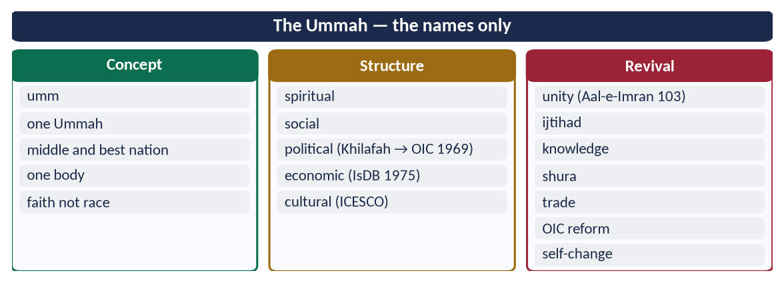
Figure 3 · At a glance — the Ummah — the names only. The detail is in the sections above.

(6) Conclusion
✦ SCHOLARLY VIEW
Allama Muhammad Iqbal · Bang-e-Dra
'Aik hon Muslim Haram ki pasbani ke liye / Neel ke sahil se le kar tabak-e-khak-e-Kashghar' — let the Muslims unite to guard the Haram, from the Nile to Kashghar.
➜ The dream of unity.

The Ummah is one in faith, many in states. Its structure — spiritual, social, political, economic and cultural — survives, but its strength has been lost to disunity, stagnation and injustice. Revival will come through unity, ijtihad, knowledge, good governance and self-reform — exactly what the Quran prescribed.

Why this answer scores
- Three limbs, three headings — concept, structure, revival.
- A brief diagnosis of decline makes the suggestions logical.
- The structure is shown in a figure with facts (632–1924, OIC 1969, IsDB 1975).

Answer 2 · Islamic Ideology and Modern Western Thought on Individuality (CSS 2015)
THE QUESTION · CSS 2015 · Q9 · 16 marks
Give a comparison of Islamic ideology and modern Western thought about present trends of individuality.

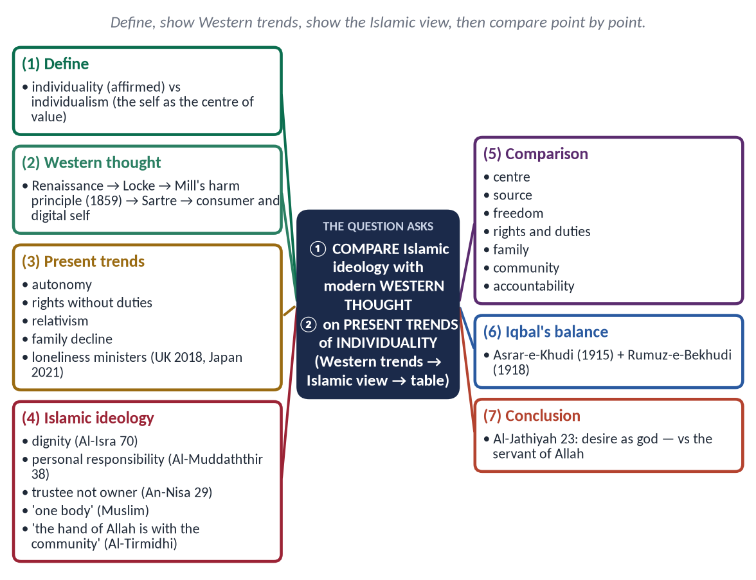
Figure 4 · The answer map: every branch is one numbered heading of the model answer below.

Decoding the question
- 'Comparison' — point-by-point, ideally in a table.
- 'Present trends of individuality' — today's trends, not only the history of ideas.
- 16 marks — concise but complete.

The model answer

(1) Introduction
Modern Western civilization places the individual at its centre; Islam places Allah at the centre and the individual as His servant and vicegerent. Both value the person — but in very different ways, with very different results for family and society.

(2) Individuality and individualism
- Individuality — each person's unique dignity, conscience and responsibility; Islam affirms it.
- Individualism — the philosophy that the self is the measure of all value and its freedom the highest good; Islam rejects its extreme form.

(3) Modern Western thought
- Renaissance humanism — man at the centre.
- John Locke (17th c.) — natural rights of life, liberty and property.
- J. S. Mill, *On Liberty* (1859) — the harm principle: the individual may do anything that does not harm others.
- Existentialism (Sartre) — 'existence precedes essence': man creates his own meaning.
- Consumer and digital individualism — identity through choice, brands and self-display online.

(4) Present trends of individuality in the West
- Autonomy above all — 'my body, my choice'.
- Rights without duties; secularism; moral relativism.
- Decline of marriage and family; the elderly in care homes.
- Loneliness — the UK appointed a Minister for Loneliness (2018), Japan (2021).
- Redefinition of identity and family by personal choice.

(5) Islamic ideology of the individual
✦ QURAN
﴿وَلَقَدۡ كَرَّمۡنَا بَنِيٓ ءَادَمَ وَحَمَلۡنَٰهُمۡ فِي ٱلۡبَرِّ وَٱلۡبَحۡرِ وَرَزَقۡنَٰهُم مِّنَ ٱلطَّيِّبَٰتِ وَفَضَّلۡنَٰهُمۡ عَلَىٰ كَثِيرٖ مِّمَّنۡ خَلَقۡنَا تَفۡضِيلٗا﴾
“And We have certainly honored the children of Adam and carried them on the land and sea and provided for them of the good things and preferred them over much of what We have created, with [definite] preference.” (Al-Isra, Quran)
➜ 'We have honoured the children of Adam' — the dignity of each person.

✦ QURAN
﴿كُلُّ نَفۡسِۭ بِمَا كَسَبَتۡ رَهِينَةٌ﴾
“Every soul, for what it has earned, will be retained.” (Al-Muddaththir, Quran)
➜ 'Every soul is held in pledge for what it has earned' — personal responsibility.

✦ QURAN
﴿… لَا تَأۡكُلُوٓاْ أَمۡوَٰلَكُم بَيۡنَكُم بِٱلۡبَٰطِلِ إِلَّآ أَن تَكُونَ تِجَٰرَةً عَن تَرَاضٖ مِّنكُمۡۚ …﴾
“Do not consume one another's wealth unjustly, but only in lawful trade by mutual consent.” (An-Nisa, Quran)
➜ 'Do not kill yourselves' — the body is a trust, not absolute property.

✦ HADITH
يَدُ اللَّهِ مَعَ الْجَمَاعَةِ
“The hand of Allah is with the community.” (Al-Tirmidhi)
➜ The individual within the community.

✦ HADITH
مَثَلُ الْمُؤْمِنِينَ ... مَثَلُ الْجَسَدِ
“The believers are like one body.” (Muslim)
➜ Individuals as limbs of one body.

Rights are joined with duties; worship itself — congregational prayer, Zakat, Hajj — develops the individual through the community.

(6) The comparison
Point | Modern Western thought | Islamic ideology
Centre of value | The self | Allah; the self as servant and khalifah
Source of values | Choice, reason, majority | Revelation, with reason and fitrah
Freedom | Maximum; limited only by harm | Real, within the limits of Allah
Ownership of self | 'My body, my choice' | Life and body a trust (amanah)
Rights and duties | Rights first | Rights and duties together
Family | One lifestyle among many | A sacred institution
Community | Voluntary association | The Ummah — one body
Accountability | Law and conscience | Law, conscience and the Hereafter
Result | Creativity and liberty; but loneliness, family decline | Dignity with belonging; freedom with responsibility

(7) Iqbal's synthesis — Khudi and Bekhudi
✦ SCHOLARLY VIEW
Allama Muhammad Iqbal · Asrar-e-Khudi (1915); Rumuz-e-Bekhudi (1918)
Iqbal taught that the individual must develop his khudi (selfhood) through faith and action, but reaches fulfilment only in the millat (community): 'Fard qaim rabt-e-millat se hai, tanha kuch nahin / Mauj hai darya mein aur bairun-e-darya kuch nahin'.
➜ The wave and the river.

(8) The trend among Muslims
Social media and globalisation are spreading individualism among Muslim youth. The answer is not to crush individuality but to root it in faith and community.

(8a) The evidence of consequences
Area | What extreme individualism has produced
Family | Fewer and later marriages; high divorce; many children with one parent
Old age | The elderly alone; the US Surgeon General declared a 'loneliness epidemic' (2023)
Mental health | Rising anxiety and depression among the young
Community | Decline of neighbourhood and voluntary ties (Robert Putnam, Bowling Alone, 2000)
Morality | Relativism — no shared standard of right and wrong

(8b) What Islam appreciates in Western individuality
Respect for personal dignity, freedom of conscience, privacy, initiative and the rule of law — all taught by Islam itself (Al-Isra 70; Al-Baqarah 256; An-Nur 27). The difference is not in valuing the person, but in where the person's value comes from and what limits his freedom.

(8c) The trend among Pakistani youth
Social media, Western entertainment and urban life are spreading individualism among the young: less time with family, choices made without consulting elders, identity built on online image. The remedy is not to suppress individuality but to connect it to faith (khudi) and community (bekhudi) — through family time, mosque and youth programmes, and education that builds both confidence and responsibility.
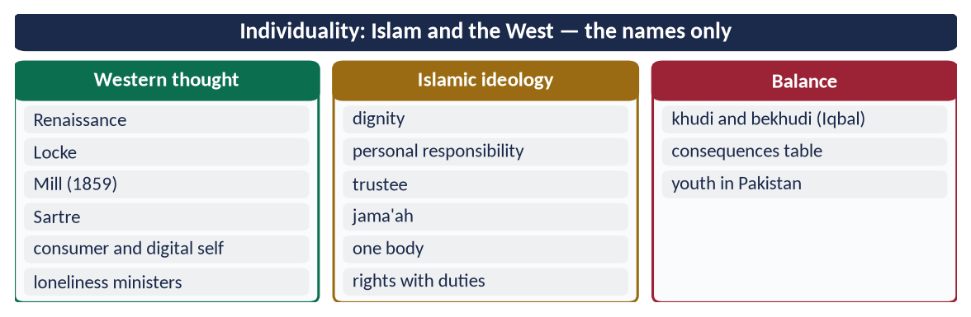
Figure 5 · At a glance — individuality: Islam and the West — the names only. The detail is in the sections above.

(9) Conclusion
✦ QURAN
﴿أَفَرَءَيۡتَ مَنِ ٱتَّخَذَ إِلَٰهَهُۥ هَوَىٰهُ وَأَضَلَّهُ ٱللَّهُ عَلَىٰ عِلۡمٖ وَخَتَمَ عَلَىٰ سَمۡعِهِۦ وَقَلۡبِهِۦ وَجَعَلَ عَلَىٰ بَصَرِهِۦ غِشَٰوَةٗ فَمَن يَهۡدِيهِ مِنۢ بَعۡدِ ٱللَّهِۚ أَفَلَا تَذَكَّرُونَ﴾
“Have you seen he who has taken as his god his [own] desire, and Allah has sent him astray due to knowledge and has set a seal upon his hearing and his heart and put over his vision a veil? So who will guide him after Allah? Then will you not be reminded.” (Al-Jathiyah, Quran)
➜ 'Have you seen the one who takes his own desire as his god?'

Western individualism frees the self but often leaves it alone; Islamic ideology honours the self and places it within family and Ummah under Allah. The Islamic balance — Iqbal's khudi within bekhudi — is the answer to the loneliness of the modern age.

Why this answer scores
- A clear definition separates individuality from individualism.
- Present trends are shown with evidence (loneliness ministers).
- A nine-row comparison table and Iqbal's synthesis give depth.

Answer 3 · Contemporary Challenges of the Muslim World and Their Solutions (CSS 2016)
THE QUESTION · CSS 2016 · Q8 · 20 marks
What are the contemporary challenges of Muslim world? Suggest its solutions in the light of Quran and Sunnah?

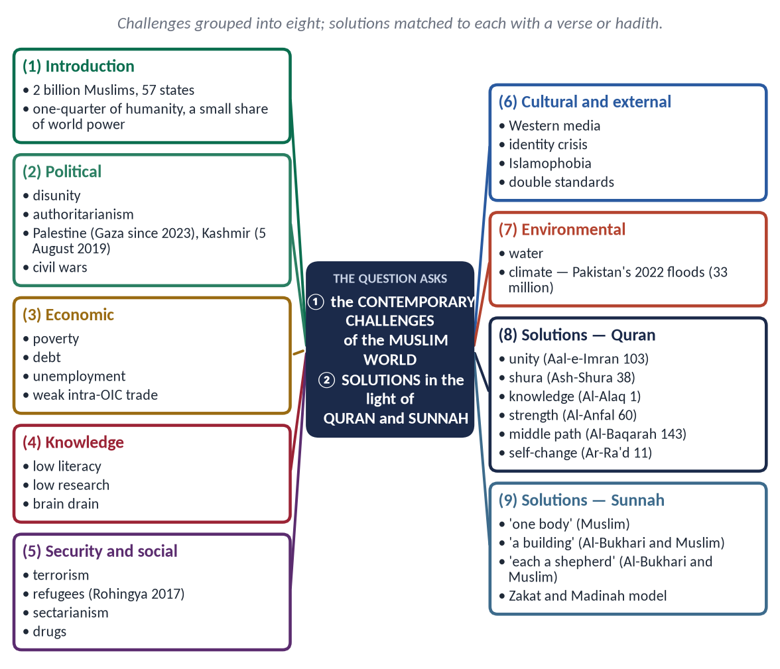
Figure 6 · The answer map: every branch is one numbered heading of the model answer below.

Decoding the question
- 'Contemporary challenges' — today's problems, grouped, with facts.
- 'Solutions in the light of Quran and Sunnah' — each solution must carry a verse or hadith, plus a practical step.

The model answer

(1) Introduction
The Muslim world has about two billion people, 57 states, vast energy reserves and a strategic location from Morocco to Indonesia. Yet it contributes far less than its share to world knowledge, wealth and power, and many of its people suffer war, poverty and occupation. Its challenges are internal and external; the Quran and Sunnah offer the way out.
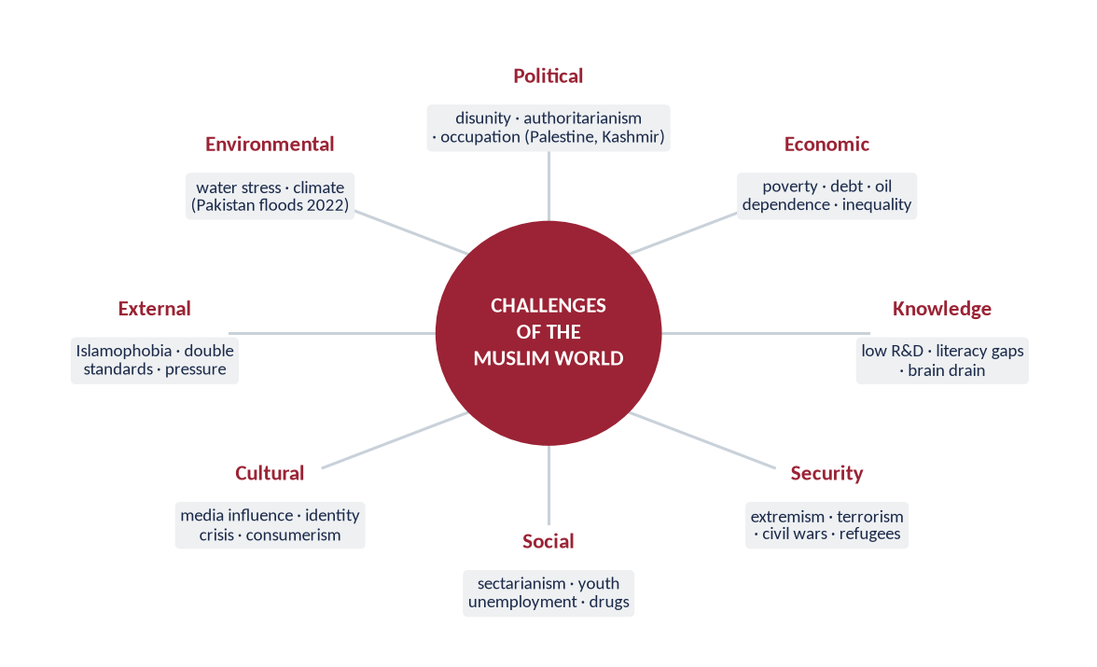
Figure 7 · The eight groups of challenges.

(2) The contemporary challenges

(i) Political
- Disunity between Muslim states; an OIC unable to act together.
- Authoritarianism and weak institutions — little accountability.
- Occupation and war — Palestine (war in Gaza since October 2023, more than 60,000 killed by mid-2025, Gaza health authorities); Kashmir (special status revoked on 5 August 2019); civil wars in Syria, Yemen, Sudan, Libya.

(ii) Economic
Poverty and inequality; debt and IMF dependence; reliance on oil or remittances; youth unemployment; intra-OIC trade only about a fifth of members' trade.

(iii) Educational and scientific
Low literacy in several countries (Pakistan about 60 percent); research spending well under 1 percent of GDP in most; brain drain — over 800,000 Pakistanis went abroad for work in 2023.

(iv) Security
Extremism and terrorism — killing Muslims more than anyone; millions of refugees (Syria, Afghanistan, Sudan, the Rohingya, over 700,000 of whom fled in 2017).

(v) Social
Sectarianism; drug abuse; family breakdown; corruption.

(vi) Cultural and ideological
Western media shaping youth; identity crisis; materialism; the gap between religious and modern education.

(vii) External
Islamophobia; double standards in international law.

(viii) Environmental
Water scarcity; climate change — Pakistan, with under 1 percent of global emissions, suffered the 2022 floods that affected about 33 million people.

(3) The solutions in the light of the Quran and Sunnah

(i) Unity
✦ QURAN
﴿وَٱعۡتَصِمُواْ بِحَبۡلِ ٱللَّهِ جَمِيعٗا وَلَا تَفَرَّقُواْۚ وَٱذۡكُرُواْ نِعۡمَتَ ٱللَّهِ عَلَيۡكُمۡ إِذۡ كُنتُمۡ أَعۡدَآءٗ فَأَلَّفَ بَيۡنَ قُلُوبِكُمۡ فَأَصۡبَحۡتُم بِنِعۡمَتِهِۦٓ إِخۡوَٰنٗا …﴾
“And hold firmly to the rope of Allah all together and do not become divided. Remember Allah's favour upon you: you were enemies, and He brought your hearts together, and by His favour you became brothers.” (Aal-e-Imran, Quran)
➜ 'Hold fast to the rope of Allah all together and do not be divided.'

✦ HADITH
الْمُؤْمِنُ لِلْمُؤْمِنِ كَالْبُنْيَانِ يَشُدُّ بَعْضُهُ بَعْضًا
“The believer to the believer is like a building whose parts support one another.” (Al-Bukhari and Muslim)

Step: a reformed OIC with binding mechanisms; mediation between Muslim states.

(ii) Good governance and justice
✦ QURAN
﴿وَٱلَّذِينَ ٱسۡتَجَابُواْ لِرَبِّهِمۡ وَأَقَامُواْ ٱلصَّلَوٰةَ وَأَمۡرُهُمۡ شُورَىٰ بَيۡنَهُمۡ وَمِمَّا رَزَقۡنَٰهُمۡ يُنفِقُونَ﴾
“And those who have responded to their lord and established prayer and whose affair is [determined by] consultation among themselves, and from what We have provided them, they spend.” (Ash-Shura, Quran)
➜ Their affairs are by consultation among themselves.

✦ QURAN
﴿إِنَّ ٱللَّهَ يَأۡمُرُكُمۡ أَن تُؤَدُّواْ ٱلۡأَمَٰنَٰتِ إِلَىٰٓ أَهۡلِهَا وَإِذَا حَكَمۡتُم بَيۡنَ ٱلنَّاسِ أَن تَحۡكُمُواْ بِٱلۡعَدۡلِۚ إِنَّ ٱللَّهَ نِعِمَّا يَعِظُكُم بِهِۦٓۗ إِنَّ ٱللَّهَ كَانَ سَمِيعَۢا بَصِيرٗا﴾
“Indeed, Allah commands you to render trusts to whom they are due and when you judge between people to judge with justice. Excellent is that which Allah instructs you. Indeed, Allah is ever Hearing and Seeing.” (An-Nisa, Quran)
➜ Render trusts to their owners and judge with justice.

Step: accountable governments, rule of law, anti-corruption.

(iii) Economic justice
✦ QURAN
﴿… كَيۡ لَا يَكُونَ دُولَةَۢ بَيۡنَ ٱلۡأَغۡنِيَآءِ مِنكُمۡۚ …﴾
“… so that it does not circulate only among the rich among you.” (Al-Hashr, Quran)
➜ So that wealth does not circulate only among the rich.

Step: Zakat systems; riba-free finance; an Islamic common market; the IsDB.

(iv) Knowledge
✦ QURAN
﴿ٱقۡرَأۡ بِٱسۡمِ رَبِّكَ ٱلَّذِي خَلَقَ﴾
“Recite in the name of your Lord who created.” (Al-Alaq, Quran)
➜ 'Read in the name of your Lord.'

✦ QURAN
﴿… يَرۡفَعِ ٱللَّهُ ٱلَّذِينَ ءَامَنُواْ مِنكُمۡ وَٱلَّذِينَ أُوتُواْ ٱلۡعِلۡمَ دَرَجَٰتٖۚ …﴾
“Allah will raise those who have believed among you and those who were given knowledge, by degrees.” (Al-Mujadilah, Quran)
➜ Allah raises those given knowledge by degrees.

Step: research funding, science programmes (COMSTECH), universities, technology of our own.

(v) Strength and self-reliance
✦ QURAN
﴿وَأَعِدُّواْ لَهُم مَّا ٱسۡتَطَعۡتُم مِّن قُوَّةٖ وَمِن رِّبَاطِ ٱلۡخَيۡلِ تُرۡهِبُونَ بِهِۦ عَدُوَّ ٱللَّهِ وَعَدُوَّكُمۡ …﴾
“Prepare against them whatever you are able of power and of steeds of war, by which you may deter the enemy of Allah and your enemy.” (Al-Anfal, Quran)
➜ 'Prepare whatever strength you can' — to deter.

Step: defence cooperation; industrial self-reliance.

(vi) Against extremism and sectarianism
✦ QURAN
﴿وَكَذَٰلِكَ جَعَلۡنَٰكُمۡ أُمَّةٗ وَسَطٗا لِّتَكُونُواْ شُهَدَآءَ عَلَى ٱلنَّاسِ وَيَكُونَ ٱلرَّسُولُ عَلَيۡكُمۡ شَهِيدٗاۗ …﴾
“And thus We have made you a middle (just) nation, that you may be witnesses over mankind and the Messenger a witness over you.” (Al-Baqarah, Quran)
➜ A middle nation.

✦ QURAN
﴿إِنَّ ٱلَّذِينَ فَرَّقُواْ دِينَهُمۡ وَكَانُواْ شِيَعٗا لَّسۡتَ مِنۡهُمۡ فِي شَيۡءٍۚ إِنَّمَآ أَمۡرُهُمۡ إِلَى ٱللَّهِ ثُمَّ يُنَبِّئُهُم بِمَا كَانُواْ يَفۡعَلُونَ﴾
“Indeed, those who have divided their religion and become sects - you, [O Muhammad], are not [associated] with them in anything. Their affair is only [left] to Allah; then He will inform them about what they used to do.” (Al-An'am, Quran)
➜ Those who divide their religion into sects — you have nothing to do with them.

Step: counter-narratives such as Paigham-e-Pakistan (2018); respect for all schools; education.

(vii) For the oppressed
✦ QURAN
﴿وَمَا لَكُمۡ لَا تُقَٰتِلُونَ فِي سَبِيلِ ٱللَّهِ وَٱلۡمُسۡتَضۡعَفِينَ مِنَ ٱلرِّجَالِ وَٱلنِّسَآءِ وَٱلۡوِلۡدَٰنِ …﴾
“What is wrong with you that you do not fight in the cause of Allah and for the oppressed among men, women and children?” (An-Nisa, Quran)
➜ What is wrong with you that you do not act for the oppressed men, women and children?

Step: diplomacy, UN and ICJ, humanitarian aid for Palestine, Kashmir and the Rohingya.

(viii) Culture and youth
✦ QURAN
﴿ٱلَّذِينَ يَسۡتَمِعُونَ ٱلۡقَوۡلَ فَيَتَّبِعُونَ أَحۡسَنَهُۥٓۚ أُوْلَـٰٓئِكَ ٱلَّذِينَ هَدَىٰهُمُ ٱللَّهُۖ وَأُوْلَـٰٓئِكَ هُمۡ أُوْلُواْ ٱلۡأَلۡبَٰبِ﴾
“Who listen to speech and follow the best of it. Those are the ones Allah has guided, and those are people of understanding.” (Az-Zumar, Quran)
➜ Those who listen and follow the best of it.

Step: quality media; integrated education; youth skills and jobs.

(ix) Environment
✦ QURAN
﴿وَٱلسَّمَآءَ رَفَعَهَا وَوَضَعَ ٱلۡمِيزَانَ ۝ أَلَّا تَطۡغَوۡاْ فِي ٱلۡمِيزَانِ ۝ وَأَقِيمُواْ ٱلۡوَزۡنَ بِٱلۡقِسۡطِ وَلَا تُخۡسِرُواْ ٱلۡمِيزَانَ﴾
“And the heaven He raised and imposed the balance. That you not transgress within the balance. And establish weight in justice and do not make deficient the balance.” (Ar-Rahman, Quran)
➜ Do not transgress the balance.

Step: climate diplomacy; water management; tree planting ('plant the sapling' — Ahmad).

(x) Self-reform
✦ QURAN
﴿… إِنَّ ٱللَّهَ لَا يُغَيِّرُ مَا بِقَوۡمٍ حَتَّىٰ يُغَيِّرُواْ مَا بِأَنفُسِهِمۡۗ …﴾
“Indeed, Allah will not change the condition of a people until they change what is in themselves.” (Ar-Ra'd, Quran)
➜ Allah does not change a people until they change what is in themselves.

✦ HADITH
كُلُّكُمْ رَاعٍ وَكُلُّكُمْ مَسْئُولٌ عَنْ رَعِيَّتِهِ
“Each of you is a shepherd and each is responsible for his flock.” (Al-Bukhari and Muslim)

(3a) Two case notes

(i) Palestine
Balfour Declaration (1917) → the Nakba (1948), about 700,000 Palestinians displaced → occupation of the West Bank, East Jerusalem and Gaza (1967; UNSC Resolution 242) → the Oslo Accords (1993) without a Palestinian state → the war in Gaza since October 2023 → the ICJ's provisional measures (January 2024) and advisory opinion that the occupation is unlawful (July 2024).
✦ QURAN
﴿سُبۡحَٰنَ ٱلَّذِيٓ أَسۡرَىٰ بِعَبۡدِهِۦ لَيۡلٗا مِّنَ ٱلۡمَسۡجِدِ ٱلۡحَرَامِ إِلَى ٱلۡمَسۡجِدِ ٱلۡأَقۡصَا ٱلَّذِي بَٰرَكۡنَا حَوۡلَهُۥ لِنُرِيَهُۥ مِنۡ ءَايَٰتِنَآۚ إِنَّهُۥ هُوَ ٱلسَّمِيعُ ٱلۡبَصِيرُ﴾
“Exalted is He who took His Servant by night from al-Masjid al-Haram to al-Masjid al-Aqsa, whose surroundings We have blessed, to show him of Our signs. Indeed, He is the Hearing, the Seeing.” (Al-Isra, Quran)
➜ Glory be to Him who took His servant by night from the Sacred Mosque to Al-Masjid al-Aqsa, whose surroundings We have blessed.

(ii) Kashmir
Disputed since 1947; UNSC Resolution 47 (1948) — a plebiscite never held; 5 August 2019 — India revoked Articles 370 and 35-A; the OIC Contact Group on Kashmir continues to raise the issue.

(3b) The role of the OIC and of Pakistan
The OIC has the numbers (57 states) but lacks binding power; it must become an instrument of collective action. Pakistan — an OIC founder, the only Muslim nuclear power, host of millions of Afghan refugees and a leading UN peacekeeper — can lead by example: stability, good governance and mediation between Muslim states.
✦ QURAN
﴿وَإِن طَآئِفَتَانِ مِنَ ٱلۡمُؤۡمِنِينَ ٱقۡتَتَلُواْ فَأَصۡلِحُواْ بَيۡنَهُمَاۖ …﴾
“And if two groups of the believers fight, then make peace between them.” (Al-Hujurat, Quran)
➜ If two groups of believers fight, make peace between them — with justice.

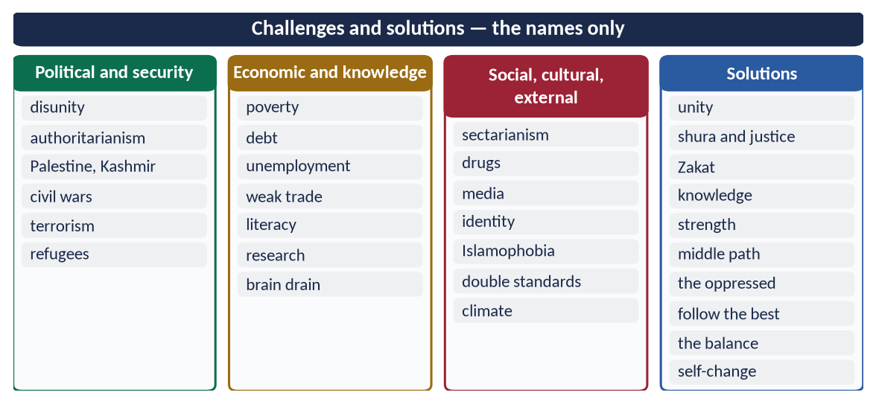
Figure 8 · At a glance — challenges and solutions — the names only. The detail is in the sections above.

(4) Conclusion
✦ SCHOLARLY VIEW
Allama Muhammad Iqbal · Bang-e-Dra
'Afrad ke hathon mein hai aqwam ki taqdeer / Har fard hai millat ke muqaddar ka sitara' — the destiny of nations lies in the hands of individuals; each individual is a star of the nation's fate.
➜ Revival begins with individuals.

The challenges of the Muslim world — political, economic, intellectual, social and external — are serious but not permanent. The Quran and Sunnah give both the diagnosis (disunity, injustice, ignorance) and the cure (unity, justice, knowledge, strength and self-reform). The Ummah that led the world once can do so again.

Why this answer scores
- Eight groups of challenges with current facts.
- Ten solutions, each with a verse or hadith and a practical step — 'in the light of the Quran and Sunnah'.
- A figure and Iqbal's verse frame the answer.

Answer 4 · Islam's Teachings on Co-existence in a Multi-faith Society (CSS 2021)
THE QUESTION · CSS 2021 · Q4 · 20 marks
Comment on the teachings of Islam regarding co-existence in a multi-faith society.

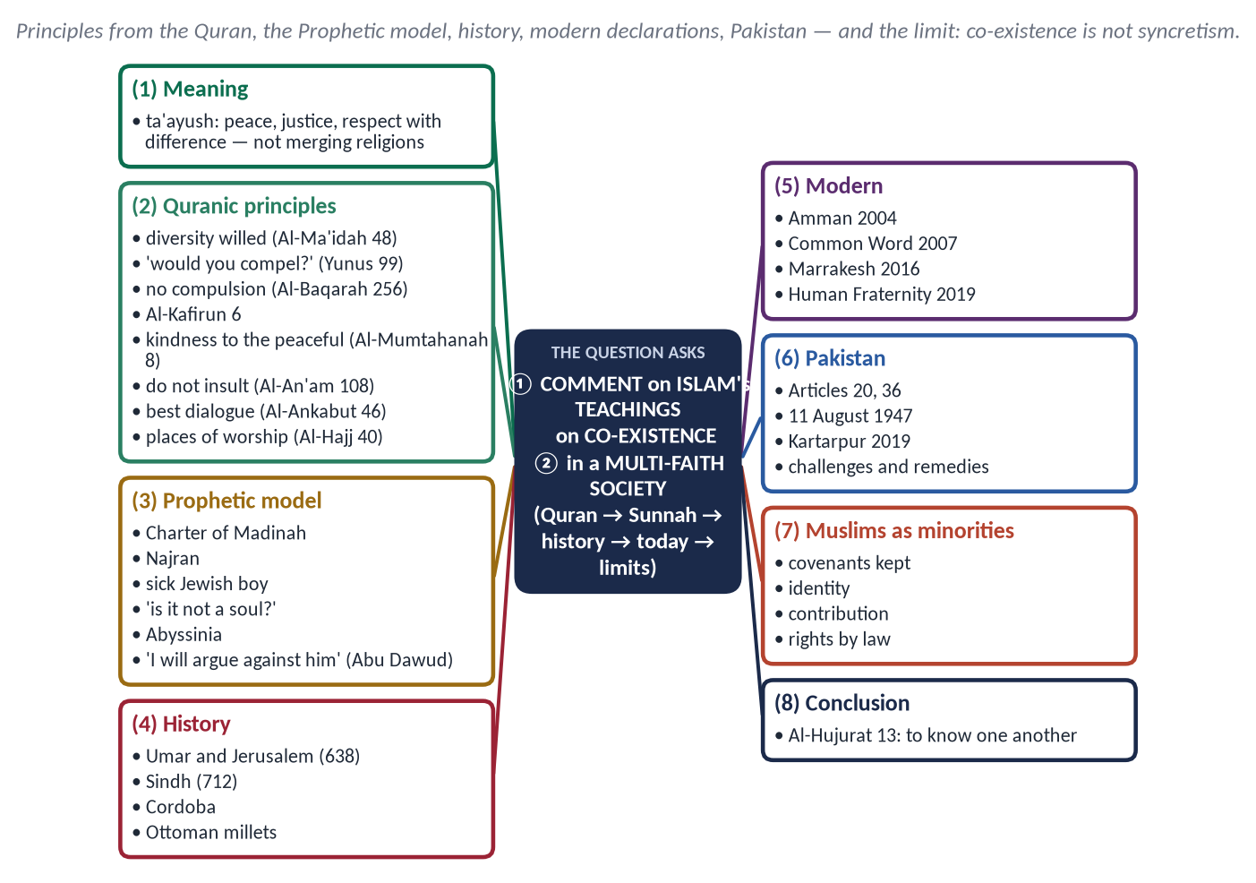
Figure 9 · The answer map: every branch is one numbered heading of the model answer below.

Decoding the question
- 'Comment' — present the teachings and your judgement: their relevance, and the gap in practice.
- 'Multi-faith society' — both Muslim-majority states with minorities and Muslims living as minorities.

The model answer

(1) Introduction
Most societies today are multi-faith: Pakistan has Hindus, Christians and Sikhs; about a third of the world's Muslims live as minorities. How people of different faiths live together is one of the great questions of the age. Islam answered it fourteen centuries ago: co-existence — ta'ayush (تَعَايُش) — peace, justice and respect with difference, without merging beliefs.

(2) The Quranic principles

(i) Diversity is Allah's will
✦ QURAN
﴿وَأَنزَلۡنَآ إِلَيۡكَ ٱلۡكِتَٰبَ بِٱلۡحَقِّ مُصَدِّقٗا لِّمَا بَيۡنَ يَدَيۡهِ مِنَ ٱلۡكِتَٰبِ وَمُهَيۡمِنًا عَلَيۡهِۖ …﴾
“And We have revealed to you the Book in truth, confirming the Scripture that came before it and as a criterion (muhaymin) over it.” (Al-Ma'idah, Quran)
➜ Had Allah willed, He would have made you one community; but He tests you in what He has given you — so compete in good deeds.

✦ QURAN
﴿وَلَوۡ شَآءَ رَبُّكَ لَأٓمَنَ مَن فِي ٱلۡأَرۡضِ كُلُّهُمۡ جَمِيعًاۚ أَفَأَنتَ تُكۡرِهُ ٱلنَّاسَ حَتَّىٰ يَكُونُواْ مُؤۡمِنِينَ﴾
“And had your Lord willed, those on earth would have believed - all of them entirely. Then, [O Muhammad], would you compel the people in order that they become believers.” (Yunus, Quran)
➜ Had your Lord willed, all on earth would have believed; would you compel people until they become believers?

(ii) No compulsion — freedom of belief
✦ QURAN
﴿لَآ إِكۡرَاهَ فِي ٱلدِّينِۖ قَد تَّبَيَّنَ ٱلرُّشۡدُ مِنَ ٱلۡغَيِّۚ …﴾
“There is no compulsion in religion; the right course has become clear from the wrong.” (Al-Baqarah, Quran)
➜ No compulsion in religion.

✦ QURAN
﴿لَكُمۡ دِينُكُمۡ وَلِيَ دِينِ﴾
“For you is your religion, and for me is my religion.” (Al-Kafirun, Quran)
➜ 'For you your religion, and for me mine.'

(iii) Justice and kindness to peaceful non-Muslims
✦ QURAN
﴿لَّا يَنۡهَىٰكُمُ ٱللَّهُ عَنِ ٱلَّذِينَ لَمۡ يُقَٰتِلُوكُمۡ فِي ٱلدِّينِ وَلَمۡ يُخۡرِجُوكُم مِّن دِيَٰرِكُمۡ أَن تَبَرُّوهُمۡ وَتُقۡسِطُوٓاْ إِلَيۡهِمۡۚ إِنَّ ٱللَّهَ يُحِبُّ ٱلۡمُقۡسِطِينَ﴾
“Allah does not forbid you from those who do not fight you because of religion and do not expel you from your homes - from being righteous toward them and acting justly toward them. Indeed, Allah loves those who act justly.” (Al-Mumtahanah, Quran)
➜ Allah does not forbid you kindness and justice to those who do not fight you because of religion or expel you from your homes.

(iv) Respect for what others hold sacred
✦ QURAN
﴿وَلَا تَسُبُّواْ ٱلَّذِينَ يَدۡعُونَ مِن دُونِ ٱللَّهِ فَيَسُبُّواْ ٱللَّهَ عَدۡوَۢا بِغَيۡرِ عِلۡمٖۗ …﴾
“Do not insult those they invoke besides Allah, lest they insult Allah in enmity, without knowledge.” (Al-An'am, Quran)
➜ 'Do not insult those they invoke besides Allah, lest they insult Allah in ignorance.'

(v) Dialogue in the best manner
✦ QURAN
﴿وَلَا تُجَٰدِلُوٓاْ أَهۡلَ ٱلۡكِتَٰبِ إِلَّا بِٱلَّتِي هِيَ أَحۡسَنُ …﴾
“And do not argue with the People of the Scripture except in the way that is best.” (Al-Ankabut, Quran)
➜ 'Do not argue with the People of the Scripture except in the way that is best.'

✦ QURAN
﴿قُلۡ يَـٰٓأَهۡلَ ٱلۡكِتَٰبِ تَعَالَوۡاْ إِلَىٰ كَلِمَةٖ سَوَآءِۭ بَيۡنَنَا وَبَيۡنَكُمۡ أَلَّا نَعۡبُدَ إِلَّا ٱللَّهَ وَلَا نُشۡرِكَ بِهِۦ شَيۡـٔٗا وَلَا يَتَّخِذَ بَعۡضُنَا بَعۡضًا أَرۡبَابٗا مِّن دُونِ ٱللَّهِۚ …﴾
“Say: O People of the Scripture, come to a word common between us and you: that we worship none but Allah, associate nothing with Him, and that none of us take others as lords besides Allah.” (Aal-e-Imran, Quran)
➜ 'Come to a word common between us and you.'

(vi) Protection of all places of worship
✦ QURAN
﴿… وَلَوۡلَا دَفۡعُ ٱللَّهِ ٱلنَّاسَ بَعۡضَهُم بِبَعۡضٖ لَّهُدِّمَتۡ صَوَٰمِعُ وَبِيَعٞ وَصَلَوَٰتٞ وَمَسَٰجِدُ يُذۡكَرُ فِيهَا ٱسۡمُ ٱللَّهِ كَثِيرٗاۗ …﴾
“Were it not that Allah checks some people by means of others, monasteries, churches, synagogues and mosques — in which Allah's name is much mentioned — would have been demolished.” (Al-Hajj, Quran)
➜ Were it not for Allah's check, monasteries, churches, synagogues and mosques would be destroyed.

(vii) One human family
✦ QURAN
﴿يَـٰٓأَيُّهَا ٱلنَّاسُ إِنَّا خَلَقۡنَٰكُم مِّن ذَكَرٖ وَأُنثَىٰ وَجَعَلۡنَٰكُمۡ شُعُوبٗا وَقَبَآئِلَ لِتَعَارَفُوٓاْۚ إِنَّ أَكۡرَمَكُمۡ عِندَ ٱللَّهِ أَتۡقَىٰكُمۡۚ إِنَّ ٱللَّهَ عَلِيمٌ خَبِيرٞ﴾
“O mankind, indeed We have created you from male and female and made you peoples and tribes that you may know one another. Indeed, the most noble of you in the sight of Allah is the most righteous of you. Indeed, Allah is Knowing and Acquainted.” (Al-Hujurat, Quran)
➜ Nations and tribes were made to know one another.

(3) The Prophetic model
- The Charter of Madinah (622) — Muslims, Jews and Arab clans as one political community: 'to the Jews their religion, to the Muslims theirs'.
- The Najran treaty — Christians' churches, clergy and property protected; they prayed in the Prophet's ﷺ mosque.
- Personal conduct — he visited a sick Jewish boy; stood for a Jewish funeral ('Is it not a soul?' — Al-Bukhari and Muslim); traded with Jews and died with his armour pledged to one.
- The rights of non-Muslim citizens:
✦ HADITH
أَلَا مَنْ ظَلَمَ مُعَاهَدًا، أَوِ انْتَقَصَهُ، أَوْ كَلَّفَهُ فَوْقَ طَاقَتِهِ، أَوْ أَخَذَ مِنْهُ شَيْئًا بِغَيْرِ طِيبِ نَفْسٍ، فَأَنَا حَجِيجُهُ يَوْمَ الْقِيَامَةِ
“Whoever wrongs a non-Muslim under covenant, belittles him, burdens him beyond his capacity or takes anything from him without his consent — I will argue against him on the Day of Resurrection.” (Abu Dawud)

✦ HADITH
مَنْ قَتَلَ مُعَاهَدًا لَمْ يَرِحْ رَائِحَةَ الْجَنَّةِ
“Whoever kills a non-Muslim under covenant will not smell the fragrance of Paradise.” (Al-Bukhari)

- Muslims as a minority — Abyssinia: the Muslims lived loyally and truthfully under a just Christian king.

(4) The historical record
Umar (RA) guaranteed the churches of Jerusalem (638) and prayed outside the Holy Sepulchre; Muhammad bin Qasim protected temples in Sindh (712); Jews and Christians held office in Cordoba; the Ottoman millet system let each community govern its own religious affairs.

(5) Modern Muslim declarations
- The Amman Message (2004) — against extremism and takfir.
- A Common Word (2007) — 138 scholars: love of God and neighbour.
- The Marrakesh Declaration (2016) — the rights of religious minorities in Muslim lands, based on the Charter of Madinah.
- The Document on Human Fraternity (Abu Dhabi, 2019) — the Grand Imam of Al-Azhar and Pope Francis.

(6) Co-existence in Pakistan
- Constitution: Article 20 (religious freedom), 22 (educational safeguards), 36 (protection of minorities); reserved seats.
- The Quaid, 11 August 1947: 'You are free to go to your temples … mosques or any other place of worship.'
- Kartarpur Corridor (November 2019) — visa-free access for Sikh pilgrims.
- Paigham-e-Pakistan (2018) — scholars of all schools against violence.
PAKISTAN · THE GAP AND THE REMEDY
Hate speech, mob violence over blasphemy allegations and complaints of forced conversions contradict the teachings above. Remedy: strict rule of law against mobs; a curriculum that teaches the Charter of Madinah and the rights of the mu'ahad; interfaith councils; the ulema's leadership against incitement.

(7) Muslims as minorities
Keep lawful covenants (Al-Isra 34); preserve identity; contribute to society — 'the best of people are those most beneficial to people' (Al-Tabarani); seek rights through law; invite by example, as in Abyssinia.

(8) The limit — co-existence is not syncretism
Surah Al-Kafirun both protects others' freedom and keeps Muslim belief distinct. Islam asks for peace with difference, not the merging of faiths.

(8a) The rights of non-Muslims in an Islamic state — the list
Life, property and honour; freedom of worship and of their places of worship; their own personal law in marriage and inheritance; equal justice in court (Ali (RA) lost his case to a non-Muslim before Qadi Shurayh); welfare from the treasury (Umar's stipend to an old Jew); protection from abuse and insult; representation in public life.

(8b) The scholars
✦ SCHOLARLY VIEW
Imam Abu Yusuf · Kitab al-Kharaj
The Hanafi chief justice instructed Caliph Harun al-Rashid to treat the non-Muslim citizens with gentleness, to tax them within their means, and to protect their lives and property as the Prophet ﷺ and the Caliphs had done.
➜ Co-existence as state law.

✦ SCHOLARLY VIEW
Dr Muhammad Hamidullah · The First Written Constitution in the World
Hamidullah showed that the Charter of Madinah created a plural political community — Muslims, Jews and pagans — with religious freedom and common defence: the first constitutional model of co-existence.
➜ The Charter as a model for today.

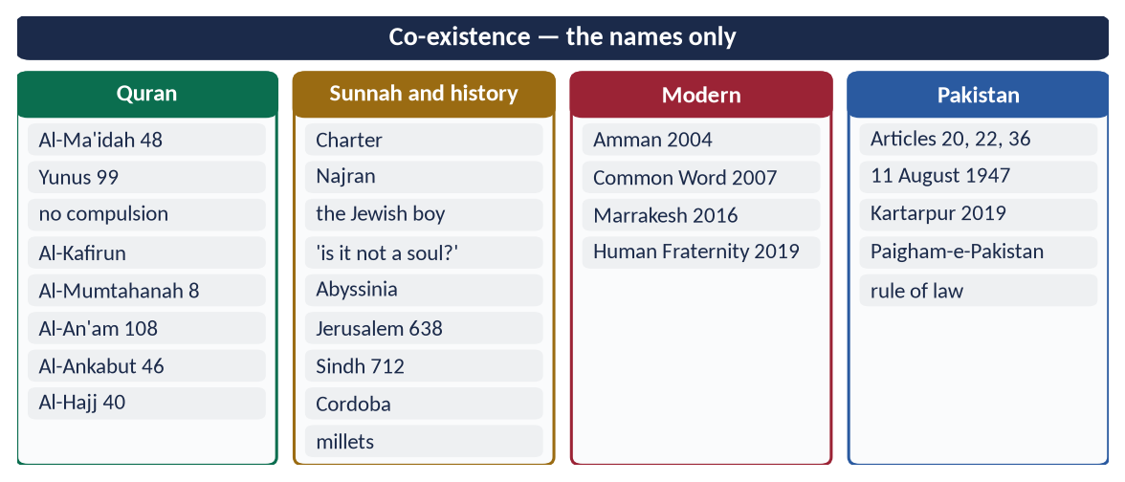
Figure 10 · At a glance — co-existence — the names only. The detail is in the sections above.

(9) Conclusion
Islam's teachings on co-existence are clear, practical and tested in history: diversity is Allah's will, faith cannot be forced, peaceful neighbours are owed justice and kindness, sacred things of others must not be insulted, and all houses of worship are protected. The challenge today is not in the teachings but in their practice — and a Pakistan that lives by them would be the strongest reply to Islamophobia abroad.

Why this answer scores
- Comment — teachings plus judgement on practice (the Pakistan box).
- Evidence from Quran, Sunnah, history and modern declarations in order.
- Covers both Muslims with minorities and Muslims as minorities; states the limit.

Answer 5 · Islamophobia Is a Sign of Extremism: Remedies (CSS 2021)
THE QUESTION · CSS 2021 · Q5 · 20 marks
Islamophobia is a sign of extremism. Give suggestions for its remedy.

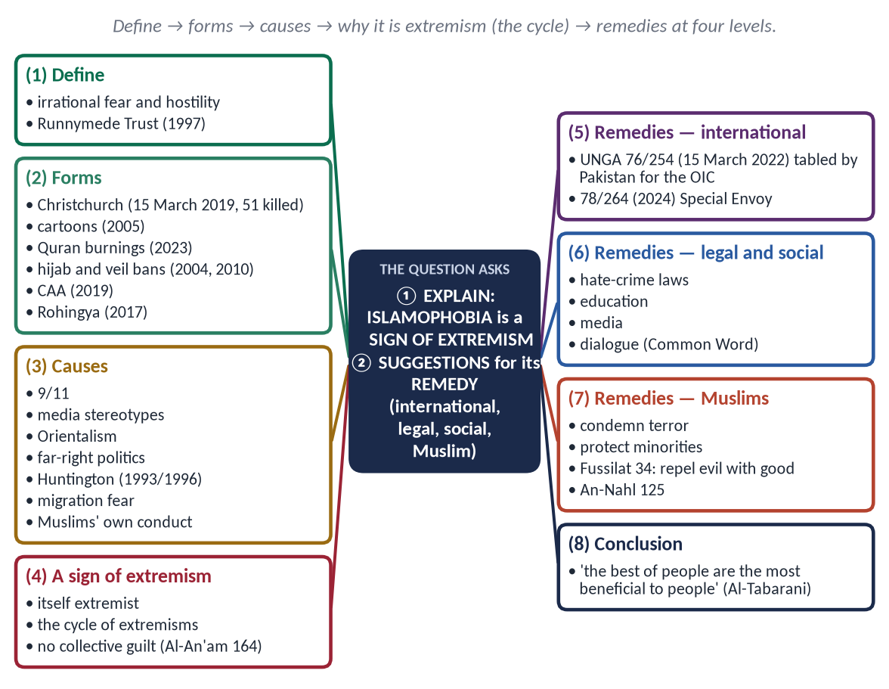
Figure 11 · The answer map: every branch is one numbered heading of the model answer below.

Decoding the question
- 'Islamophobia is a sign of extremism' — agree, and explain why — it is itself an extremism, and it feeds and is fed by Muslim extremism.
- 'Suggestions for its remedy' — practical measures at several levels, including what Muslims must do.

The model answer

(1) Introduction
Islamophobia is the irrational fear of, prejudice against, or hostility towards Islam and Muslims, which leads to discrimination, exclusion and violence. The term was popularised by the British Runnymede Trust report Islamophobia: A Challenge for Us All (1997). Since 2001 it has grown into a global problem — from mosque attacks in New Zealand to discriminatory laws in parts of Europe and India.

(2) The forms of Islamophobia
- Violence — the Christchurch mosque attacks (15 March 2019), 51 worshippers killed.
- Insult to the sacred — cartoons of the Prophet ﷺ (Denmark, 2005; later France); public burnings of the Quran (Sweden and Denmark, 2023).
- Discriminatory laws — headscarf ban in French schools (2004), face-veil ban (2010), Swiss minaret ban (2009), India's Citizenship Amendment Act (2019).
- Media and political hate — stereotypes of Islam as violent; far-right campaigns.
- Everyday discrimination — in jobs, housing, airports and schools.
- Mass persecution — the Rohingya of Myanmar (2017).

(3) The causes
- Terrorism by a few (9/11 and later attacks) exploited to blame all Muslims.
- Media stereotypes — 'Islam = terror'.
- Orientalism — centuries of hostile images (Edward Said, 1978).
- Far-right politics — fear of Muslims used for votes.
- Huntington's 'clash of civilizations' (1993/1996).
- Migration and economic fears.
- Ignorance of Islam.
- Muslims' own failures — extremism, sectarian violence, poor treatment of minorities.

(4) Why Islamophobia is a sign of extremism

(i) It is itself an extremist ideology
It judges almost two billion people by the crimes of a few, calls for their exclusion, and in its worst form kills them — the Christchurch attacker was driven by white-supremacist extremism.

(ii) It forms a cycle with Muslim extremism
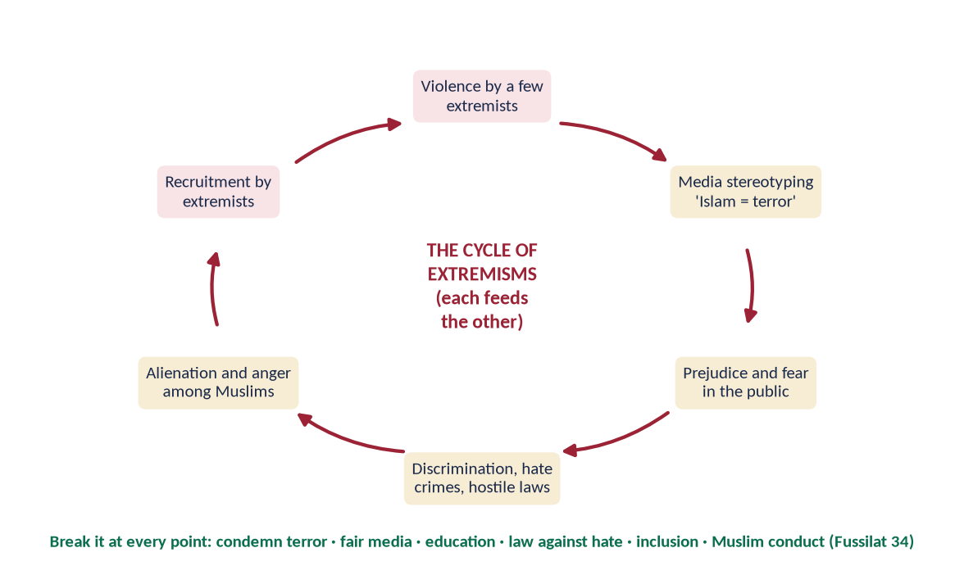
Figure 12 · The cycle of extremisms: each feeds the other.
Terror attacks → fear → discrimination → alienation of Muslims → recruitment by extremists → more attacks. Each extremism needs the other.

(iii) It violates the principle of personal responsibility
✦ QURAN
﴿… وَلَا تَزِرُ وَازِرَةٞ وِزۡرَ أُخۡرَىٰۚ …﴾
“No bearer of burdens shall bear the burden of another.” (Al-An'am, Quran)
➜ 'No bearer of burdens shall bear the burden of another.'

✦ QURAN
﴿… وَلَا يَجۡرِمَنَّكُمۡ شَنَـَٔانُ قَوۡمٍ عَلَىٰٓ أَلَّا تَعۡدِلُواْۚ ٱعۡدِلُواْ هُوَ أَقۡرَبُ لِلتَّقۡوَىٰۖ …﴾
“Do not let the hatred of a people lead you to be unjust. Be just; that is nearer to righteousness.” (Al-Ma'idah, Quran)
➜ 'Do not let the hatred of a people lead you to injustice.'

Collective blame is the mark of every extremism — and is condemned by the Quran.

(5) Suggestions for its remedy

(i) International measures
- UN General Assembly Resolution 76/254 (15 March 2022) — declared 15 March the International Day to Combat Islamophobia, on a resolution tabled by Pakistan on behalf of the OIC.
- UNGA Resolution 78/264 (2024) — 'Measures to combat Islamophobia', calling for a UN Special Envoy.
- The OIC — its Islamophobia Observatory and diplomacy.

(ii) Legal measures
Hate-crime and hate-speech laws; protection of places of worship; international norms against the deliberate insult of religious symbols, balanced with free speech.

(iii) Education and dialogue
Teaching about Islam in schools; interfaith programmes — A Common Word (2007), the Document on Human Fraternity (2019); academic and youth exchanges.

(iv) Media
Muslim journalists, writers and film-makers presenting the real Islam; challenging stereotypes; responsible reporting guidelines.

(v) What Muslims must do — the most powerful remedy
✦ QURAN
﴿وَلَا تَسۡتَوِي ٱلۡحَسَنَةُ وَلَا ٱلسَّيِّئَةُۚ ٱدۡفَعۡ بِٱلَّتِي هِيَ أَحۡسَنُ فَإِذَا ٱلَّذِي بَيۡنَكَ وَبَيۡنَهُۥ عَدَٰوَةٞ كَأَنَّهُۥ وَلِيٌّ حَمِيمٞ﴾
“And not equal are the good deed and the bad. Repel [evil] by that [deed] which is better; and thereupon the one whom between you and him is enmity [will become] as though he was a devoted friend.” (Fussilat, Quran)
➜ 'Repel evil with what is better; then your enemy will become as a devoted friend.'

✦ QURAN
﴿ٱدۡعُ إِلَىٰ سَبِيلِ رَبِّكَ بِٱلۡحِكۡمَةِ وَٱلۡمَوۡعِظَةِ ٱلۡحَسَنَةِۖ وَجَٰدِلۡهُم بِٱلَّتِي هِيَ أَحۡسَنُۚ …﴾
“Invite to the way of your Lord with wisdom and good instruction, and argue with them in the way that is best.” (An-Nahl, Quran)
➜ Invite with wisdom and good instruction, and argue in the best way.

- Condemn terrorism clearly and consistently.
- Protect minorities in Muslim countries — rights demanded abroad must be given at home.
- Contribute — Muslims in the West as doctors, teachers, volunteers; mosques as open community centres.
- Answer insult the Prophetic way — lawful, collective, diplomatic protest; dignity, not violence.
✦ QURAN
﴿إِنَّا كَفَيۡنَٰكَ ٱلۡمُسۡتَهۡزِءِينَ﴾
“Indeed, We are sufficient for you against the mockers.” (Al-Hijr, Quran)
➜ 'We are sufficient for you against the mockers.'

(vi) Learning from Christchurch
New Zealand's response — solidarity, the adhan broadcast nationally, women wearing headscarves in sympathy, and swift gun-law reform — showed that societies can defeat Islamophobia together.

(5a) Pakistan's role against Islamophobia
- Tabled Resolution 76/254 (2022) at the UN on behalf of the OIC.
- After the Quran burnings of 2023, led the OIC call in the UN Human Rights Council, which adopted a resolution against religious hatred.
- Works with the OIC for a UN Special Envoy (Resolution 78/264, 2024).
- At home, Pakistan's own record on minorities is its strongest or weakest argument — the rights it demands for Muslims abroad must be given to minorities at home.

(5b) The role of the Muslim diaspora
Muslims in the West answer hostility with contribution: doctors on the front line of COVID-19, mosques running food banks, athletes, writers and politicians changing perceptions. After Christchurch, New Zealand's solidarity — the adhan broadcast nationally, women wearing headscarves in sympathy — showed that a society united against hate can defeat Islamophobia.
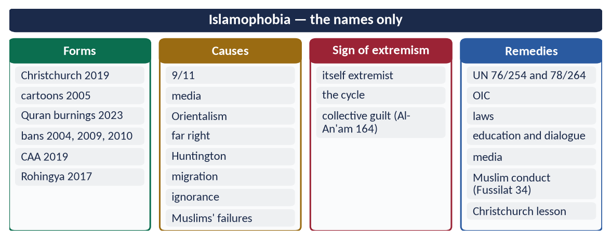
Figure 13 · At a glance — islamophobia — the names only. The detail is in the sections above.

(6) Conclusion
✦ HADITH
خَيْرُ النَّاسِ أَنْفَعُهُمْ لِلنَّاسِ
“The best of people are those most beneficial to people.” (Al-Tabarani)

Islamophobia is indeed a sign of extremism — an extremism in itself and a partner of Muslim extremism in a cycle of hatred. It must be answered by international law and education, and above all by Muslims who show, through justice and service, what Islam really is.

Why this answer scores
- It proves the claim three ways — ideology, cycle, collective guilt.
- Remedies at four levels, with UN resolution numbers and dates.
- Balanced: it asks Muslims to fix their own failures too.

Answer 6 · The Reconstruction of Pakistani Society in the Light of Islamic Teachings (CSS 2022)
THE QUESTION · CSS 2022 · Q7 · 20 marks
Explain the Reconstruction of Pakistani Society in the light of Islamic Teachings.

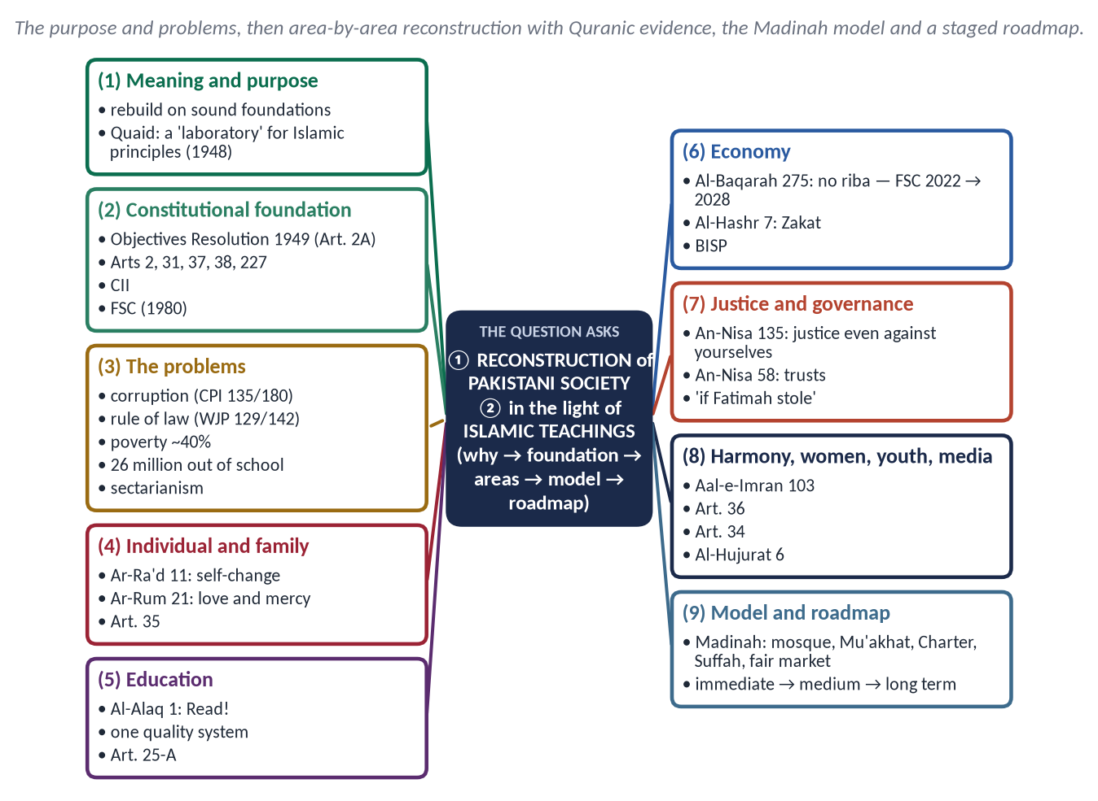
Figure 14 · The answer map: every branch is one numbered heading of the model answer below.

Decoding the question
- 'Reconstruction' — rebuilding the whole society: individual, family, institutions, economy and values.
- 'In the light of Islamic teachings' — every area supported by Quran, Sunnah and the Madinah model.
- A strong answer shows why reconstruction is needed (problems with data) and how (areas and roadmap).

The model answer

(1) Introduction
Pakistan was created in the name of Islam. The Quaid said:
✦ SCHOLARLY VIEW
Quaid-e-Azam Muhammad Ali Jinnah · Islamia College, Peshawar, 13 January 1948
Pakistan was not demanded merely to have a piece of land, but to have a laboratory where Islamic principles could be tried out.
➜ The purpose.

Seventy-eight years later, Pakistan faces corruption, injustice, poverty, sectarianism and moral decline. Reconstruction means rebuilding its individuals, families, institutions and economy on the principles for which it was founded.

(2) The constitutional foundation
- Objectives Resolution (1949) — sovereignty belongs to Allah; Muslims to live by Islam; minorities protected — now Article 2A.
- Article 31 — enable Muslims to live according to Islam.
- Articles 37–38 — social justice and the people's well-being.
- Article 227 — no law repugnant to the Quran and Sunnah; the Council of Islamic Ideology and the Federal Shariat Court (1980).

(3) Why reconstruction is needed
Problem | Evidence
Corruption | Transparency International CPI 2024: 135th of 180
Weak rule of law | World Justice Project 2024: 129th of 142
Poverty | About 40 percent below the poverty line (World Bank)
Education | About 26 million children out of school
Social division | Sectarianism, mob violence, injustice to women and minorities
Elite privilege | About 17.4 billion dollars a year (UNDP, 2021)

(4) Reconstruction area by area

(i) The individual — character first
✦ QURAN
﴿… إِنَّ ٱللَّهَ لَا يُغَيِّرُ مَا بِقَوۡمٍ حَتَّىٰ يُغَيِّرُواْ مَا بِأَنفُسِهِمۡۗ …﴾
“Indeed, Allah will not change the condition of a people until they change what is in themselves.” (Ar-Ra'd, Quran)
➜ Allah does not change a people until they change what is in themselves.

Tazkiyah through education, mosques and media: honesty, punctuality, respect for law.

(ii) The family
✦ QURAN
﴿وَمِنۡ ءَايَٰتِهِۦٓ أَنۡ خَلَقَ لَكُم مِّنۡ أَنفُسِكُمۡ أَزۡوَٰجٗا لِّتَسۡكُنُوٓاْ إِلَيۡهَا وَجَعَلَ بَيۡنَكُم مَّوَدَّةٗ وَرَحۡمَةًۚ إِنَّ فِي ذَٰلِكَ لَأٓيَٰتٖ لِّقَوۡمٖ يَتَفَكَّرُونَ﴾
“And of His signs is that He created for you from yourselves mates that you may find tranquillity in them; and He placed between you affection and mercy. Indeed in that are signs for a people who give thought.” (Ar-Rum, Quran)
➜ He placed between you love and mercy.

Easy marriage; an end to dowry culture; rights of women and children; care of the elderly (Article 35).

(iii) Education
✦ QURAN
﴿ٱقۡرَأۡ بِٱسۡمِ رَبِّكَ ٱلَّذِي خَلَقَ﴾
“Recite in the name of your Lord who created.” (Al-Alaq, Quran)
➜ 'Read!'

One quality system instead of three tracks; Article 25-A (free education, ages 5–16); science with Islamic ethics; madrasas with modern subjects.

(iv) The economy
✦ QURAN
﴿… وَأَحَلَّ ٱللَّهُ ٱلۡبَيۡعَ وَحَرَّمَ ٱلرِّبَوٰاْۚ …﴾
“Allah has permitted trade and forbidden riba (interest).” (Al-Baqarah, Quran)
➜ 'Allah has permitted trade and forbidden riba.'

✦ QURAN
﴿… كَيۡ لَا يَكُونَ دُولَةَۢ بَيۡنَ ٱلۡأَغۡنِيَآءِ مِنكُمۡۚ …﴾
“… so that it does not circulate only among the rich among you.” (Al-Hashr, Quran)
➜ So that wealth does not circulate only among the rich.

- Riba-free economy — the Federal Shariat Court's judgment of 28 April 2022; target 1 January 2028 (26th Amendment).
- Zakat and Ushr collected and spent transparently; social protection (BISP).
- Fair taxes; an end to elite privilege.

(v) Justice and rule of law
✦ QURAN
﴿يَـٰٓأَيُّهَا ٱلَّذِينَ ءَامَنُواْ كُونُواْ قَوَّـٰمِينَ بِٱلۡقِسۡطِ شُهَدَآءَ لِلَّهِ وَلَوۡ عَلَىٰٓ أَنفُسِكُمۡ أَوِ ٱلۡوَٰلِدَيۡنِ وَٱلۡأَقۡرَبِينَۚ …﴾
“O you who believe, stand firmly for justice, as witnesses for Allah, even if it be against yourselves, your parents or your relatives.” (An-Nisa, Quran)
➜ Stand firm for justice, even against yourselves, your parents and relatives.

✦ HADITH
وَايْمُ اللَّهِ لَوْ أَنَّ فَاطِمَةَ بِنْتَ مُحَمَّدٍ سَرَقَتْ لَقَطَعْتُ يَدَهَا
“By Allah, if Fatimah daughter of Muhammad stole, I would cut her hand.” (Al-Bukhari and Muslim)
➜ One law for all.

Quick, affordable justice; independent courts; no VIP exemptions.

(vi) Governance and accountability
✦ QURAN
﴿إِنَّ ٱللَّهَ يَأۡمُرُكُمۡ أَن تُؤَدُّواْ ٱلۡأَمَٰنَٰتِ إِلَىٰٓ أَهۡلِهَا وَإِذَا حَكَمۡتُم بَيۡنَ ٱلنَّاسِ أَن تَحۡكُمُواْ بِٱلۡعَدۡلِۚ إِنَّ ٱللَّهَ نِعِمَّا يَعِظُكُم بِهِۦٓۗ إِنَّ ٱللَّهَ كَانَ سَمِيعَۢا بَصِيرٗا﴾
“Indeed, Allah commands you to render trusts to whom they are due and when you judge between people to judge with justice. Excellent is that which Allah instructs you. Indeed, Allah is ever Hearing and Seeing.” (An-Nisa, Quran)
➜ Render trusts to whom they are due and judge with justice.

Merit, transparency, accountability of rulers — the model of Umar (RA).

(vii) Social harmony
✦ QURAN
﴿وَٱعۡتَصِمُواْ بِحَبۡلِ ٱللَّهِ جَمِيعٗا وَلَا تَفَرَّقُواْۚ وَٱذۡكُرُواْ نِعۡمَتَ ٱللَّهِ عَلَيۡكُمۡ إِذۡ كُنتُمۡ أَعۡدَآءٗ فَأَلَّفَ بَيۡنَ قُلُوبِكُمۡ فَأَصۡبَحۡتُم بِنِعۡمَتِهِۦٓ إِخۡوَٰنٗا …﴾
“And hold firmly to the rope of Allah all together and do not become divided. Remember Allah's favour upon you: you were enemies, and He brought your hearts together, and by His favour you became brothers.” (Aal-e-Imran, Quran)
➜ 'Hold fast to the rope of Allah together and do not be divided.'

End sectarian hate speech (Paigham-e-Pakistan, 2018); equal citizenship for minorities (Article 36; 11 August 1947).

(viii) Women and youth
Education, safety and work for women (Article 34); skills and jobs for the young — about two-thirds of Pakistanis are under 30.

(ix) Media
✦ QURAN
﴿يَـٰٓأَيُّهَا ٱلَّذِينَ ءَامَنُوٓاْ إِن جَآءَكُمۡ فَاسِقُۢ بِنَبَإٖ فَتَبَيَّنُوٓاْ أَن تُصِيبُواْ قَوۡمَۢا بِجَهَٰلَةٖ فَتُصۡبِحُواْ عَلَىٰ مَا فَعَلۡتُمۡ نَٰدِمِينَ﴾
“O you who have believed, if there comes to you a disobedient one with information, investigate, lest you harm a people out of ignorance and become, over what you have done, regretful.” (Al-Hujurat, Quran)
➜ If a sinful person brings news, verify it.

Truthful, family-friendly media; action against fake news.

(x) The environment
✦ QURAN
﴿وَٱلسَّمَآءَ رَفَعَهَا وَوَضَعَ ٱلۡمِيزَانَ ۝ أَلَّا تَطۡغَوۡاْ فِي ٱلۡمِيزَانِ ۝ وَأَقِيمُواْ ٱلۡوَزۡنَ بِٱلۡقِسۡطِ وَلَا تُخۡسِرُواْ ٱلۡمِيزَانَ﴾
“And the heaven He raised and imposed the balance. That you not transgress within the balance. And establish weight in justice and do not make deficient the balance.” (Ar-Rahman, Quran)
➜ Do not transgress the balance.

Water conservation and climate adaptation after the 2022 floods.

(xi) The role of civil society
Pakistan is among the most charitable nations — Edhi Foundation, Shaukat Khanum, Akhuwat (interest-free loans), Saylani — the Islamic spirit of service to build on.

(5) The model — the society of Madinah
Madinah | Principle | Pakistan
Mosque of the Prophet ﷺ | Faith and character | Mosques and schools that build character
Mu'akhat | Brotherhood | Social solidarity; welfare
Charter of Madinah | Constitution; pluralism | Articles 2A, 20, 36
Suffah | Education for all | Article 25-A
Market of Madinah | Honest trade; no riba | Riba-free by 2028
'If Fatimah stole' | Rule of law | Independent, quick courts

(6) A staged roadmap
- Immediate: rule of law against mobs and hate speech; quick justice in small cases; Zakat transparency.
- Medium term: one education system; madrasa reform; riba-free banking; social protection; women's safety and work.
- Long term: a research-based economy; accountable institutions; a society of trust.

(5a) The roles of the key actors
- The state: laws under Articles 31 and 227; justice, welfare, security; honesty at the top.
- The ulema: unity instead of sectarianism; Islam's social teachings from the pulpit.
- Teachers and universities: knowledge joined with character; research on national problems.
- Media: truth, responsibility, family values.
- Civil society: the charitable spirit of Edhi, Akhuwat and Saylani.
- The family: the first school.

(5b) The vision of Iqbal and the Quaid
✦ SCHOLARLY VIEW
Allama Muhammad Iqbal · Allahabad Address, 1930
Iqbal saw in a Muslim state the chance for Islam to mobilise its law, education and culture and bring them into closer contact with its own original spirit and with the spirit of modern times.
➜ Reconstruction as renewal, not mere return.

✦ SCHOLARLY VIEW
Quaid-e-Azam Muhammad Ali Jinnah · Karachi, 25 January 1948
The Quaid said that Islamic principles are as applicable to life today as they were 1,300 years ago, and that Pakistan's Constitution would embody them.
➜ Islam as a living guide.

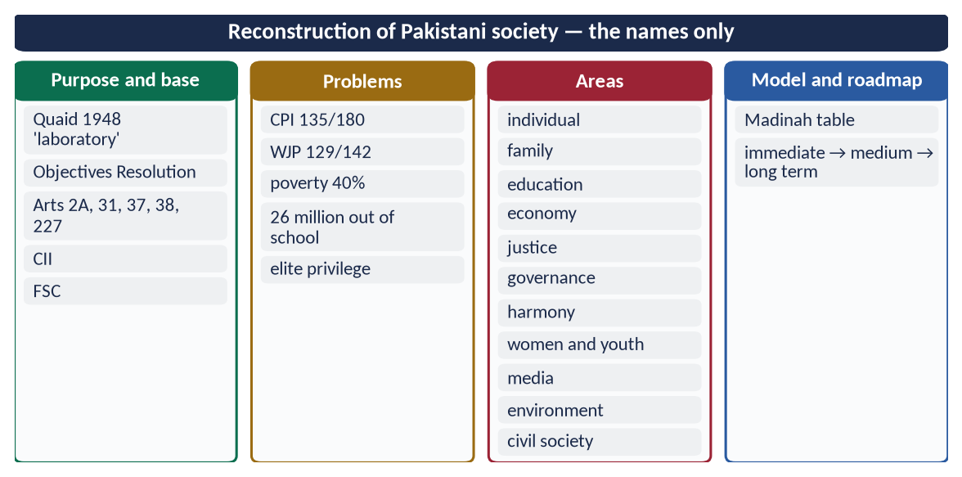
Figure 15 · At a glance — reconstruction of Pakistani society — the names only. The detail is in the sections above.

(7) Conclusion
✦ HADITH
كُلُّكُمْ رَاعٍ وَكُلُّكُمْ مَسْئُولٌ عَنْ رَعِيَّتِهِ
“Each of you is a shepherd, and each of you is responsible for his flock.” (Al-Bukhari and Muslim)

The reconstruction of Pakistani society in the light of Islam means building good individuals, strong families, just institutions and a fair economy on the model of Madinah. The Constitution already provides the framework; what is needed is sincere implementation — by the state, the ulema, teachers, media and every citizen.

Why this answer scores
- It shows why (problems with data) and how (eleven areas), each with a verse or hadith.
- The Madinah model table and roadmap make it concrete.
- Constitutional references and current data give Pakistan-specific depth.

Answer 7 · Muslim Views of Western Civilization — Identified and Analysed (CSS 2025)
THE QUESTION · CSS 2025 · Q8 · 20 marks
What views are found in today's Muslim circles about Western Civilization? Identify and analyze them.

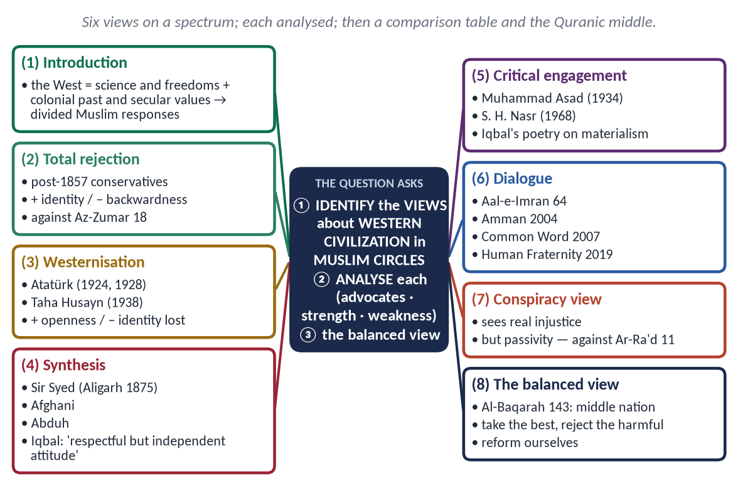
Figure 16 · The answer map: every branch is one numbered heading of the model answer below.

Decoding the question
- 'Identify' — name each view clearly, with its advocates.
- 'Analyse' — for each: its reasoning, strengths and weaknesses; then compare and conclude.
- 'Today's Muslim circles' — include present-day forms, including in Pakistan.

The model answer

(1) Introduction
Western civilization presents Muslims with a double face: it is the source of modern science, technology, democracy and human rights, and also the former coloniser and bearer of secularism, materialism and permissiveness. Muslim responses therefore range from total rejection to total imitation, with several positions between.
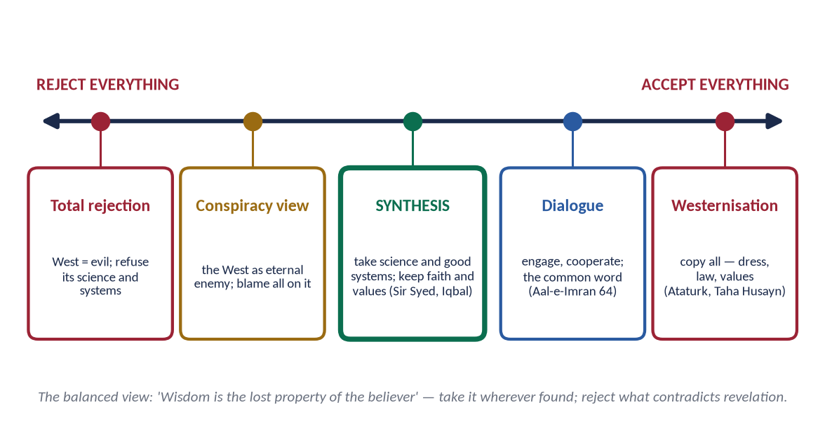
Figure 17 · Muslim views of the West on a spectrum, with synthesis at the centre.

(2) View 1 — Total rejection
The view: Western civilization is corrupt and hostile; reject its education, systems and culture.
Its roots: the trauma of colonialism; after 1857 some Muslims refused English education and government service.
Analysis:
- Strength: protects faith and identity; rightly exposes Western moral decline.
- Weakness: isolates Muslims from science; contradicts the Quranic method —
✦ QURAN
﴿ٱلَّذِينَ يَسۡتَمِعُونَ ٱلۡقَوۡلَ فَيَتَّبِعُونَ أَحۡسَنَهُۥٓۚ أُوْلَـٰٓئِكَ ٱلَّذِينَ هَدَىٰهُمُ ٱللَّهُۖ وَأُوْلَـٰٓئِكَ هُمۡ أُوْلُواْ ٱلۡأَلۡبَٰبِ﴾
“Who listen to speech and follow the best of it. Those are the ones Allah has guided, and those are people of understanding.” (Az-Zumar, Quran)
➜ Those who listen to speech and follow the best of it — they are the ones Allah has guided.

It left Indian Muslims behind in education in the 19th century — the problem Sir Syed set out to solve.

(3) View 2 — Total acceptance (Westernisation)
The view: progress requires copying the West entirely — law, dress, values and a secular state.
Advocates: Mustafa Kemal Atatürk — abolished the Caliphate (1924) and the Arabic script (1928); Taha Husayn — The Future of Culture in Egypt (1938).
Analysis:
- Strength: openness to science, education and modern administration.
- Weakness: loss of identity; an elite cut off from the believing masses; imitation did not bring equal power.

(4) View 3 — Synthesis (reform)
The view: take the West's science, technology and good systems; keep Islam's beliefs and values; use ijtihad.
Advocates: Sir Syed Ahmad Khan (Aligarh, 1875), Jamal al-Din al-Afghani, Muhammad Abduh, Allama Iqbal.
✦ SCHOLARLY VIEW
Allama Muhammad Iqbal · Preface to The Reconstruction of Religious Thought in Islam
The only course open to Muslims is to approach modern knowledge with a respectful but independent attitude.
➜ The key sentence of the synthesis.

Analysis:
- Strength: balanced, practical, faithful to Islam's own history of learning from others.
- Weakness: the line between 'science' and 'values' is not always clear; needs strong scholars and institutions.

(5) View 4 — Critical engagement
The view: study the West deeply and criticise it on its own ground — its materialism, environmental destruction and spiritual emptiness — offering Islam as an alternative civilization.
Advocates: Muhammad Asad, Islam at the Crossroads (1934); Seyyed Hossein Nasr, Man and Nature (1968); Iqbal's poetry.
✦ SCHOLARLY VIEW
Allama Muhammad Iqbal · Bal-e-Jibril
'Khira na kar saka mujhe jalwa-e-danish-e-farang / Surma hai meri aankh ka khak-e-Madina-o-Najaf' — the glitter of Western learning could not dazzle me; the dust of Madinah and Najaf is the collyrium of my eyes.
➜ Learning without being blinded.

Analysis:
- Strength: intellectual depth; a positive alternative.
- Weakness: can remain theoretical unless joined to practical reform.

(6) View 5 — Dialogue and co-existence
The view: Islam and the West share monotheistic roots and values; they should cooperate on common problems and resolve differences through dialogue.
✦ QURAN
﴿قُلۡ يَـٰٓأَهۡلَ ٱلۡكِتَٰبِ تَعَالَوۡاْ إِلَىٰ كَلِمَةٖ سَوَآءِۭ بَيۡنَنَا وَبَيۡنَكُمۡ أَلَّا نَعۡبُدَ إِلَّا ٱللَّهَ وَلَا نُشۡرِكَ بِهِۦ شَيۡـٔٗا وَلَا يَتَّخِذَ بَعۡضُنَا بَعۡضًا أَرۡبَابٗا مِّن دُونِ ٱللَّهِۚ …﴾
“Say: O People of the Scripture, come to a word common between us and you: that we worship none but Allah, associate nothing with Him, and that none of us take others as lords besides Allah.” (Aal-e-Imran, Quran)
➜ 'Come to a word common between us and you.'

Examples: the Amman Message (2004); A Common Word (2007); the Document on Human Fraternity (2019).
Analysis:
- Strength: reduces conflict and Islamophobia; Quranic in method.
- Weakness: dialogue without justice — in Palestine and Kashmir — loses credibility.

(7) View 6 — The conspiracy view
The view: every Muslim problem is a Western conspiracy.
Analysis:
- Strength: it sees real injustices — colonialism, wars, double standards.
- Weakness: it breeds passivity and hides our own failures —
✦ QURAN
﴿… إِنَّ ٱللَّهَ لَا يُغَيِّرُ مَا بِقَوۡمٍ حَتَّىٰ يُغَيِّرُواْ مَا بِأَنفُسِهِمۡۗ …﴾
“Indeed, Allah will not change the condition of a people until they change what is in themselves.” (Ar-Ra'd, Quran)
➜ Allah does not change a people until they change what is in themselves.

(8) The comparative analysis
View | Advocates | Strength | Weakness
Rejection | Post-1857 conservatives | Identity | Backwardness
Westernisation | Atatürk; Taha Husayn | Openness | Loss of identity
Synthesis | Sir Syed; Afghani; Abduh; Iqbal | Balance | Hard line to draw
Critical engagement | Asad; Nasr | Depth; alternative | Theoretical
Dialogue | Amman; Common Word | Peace | Ignored without justice
Conspiracy | Popular media | Sees injustice | Passivity

(9) The views in Pakistan today
All six can be heard: a small Westernised elite; conservative voices; a large middle class seeking modern education with Islamic values (synthesis); and a loud conspiracy discourse. The Constitution itself reflects synthesis — democratic forms (parliament, fundamental rights) under the sovereignty of Allah and Article 227.

(10) The balanced Islamic position
✦ QURAN
﴿وَكَذَٰلِكَ جَعَلۡنَٰكُمۡ أُمَّةٗ وَسَطٗا لِّتَكُونُواْ شُهَدَآءَ عَلَى ٱلنَّاسِ وَيَكُونَ ٱلرَّسُولُ عَلَيۡكُمۡ شَهِيدٗاۗ …﴾
“And thus We have made you a middle (just) nation, that you may be witnesses over mankind and the Messenger a witness over you.” (Al-Baqarah, Quran)
➜ 'We have made you a middle nation.'

Take science, technology, administration and rights; reject secularism, materialism, permissiveness and riba; engage in dialogue; and reform ourselves so that Muslims again contribute to world civilization.

(10a) Why each view arose — the historical context
- Rejection arose from the humiliation of colonialism and the fear of losing faith.
- Westernisation arose from military defeat — elites concluded that Europe's power came from its whole way of life.
- Synthesis arose from reformers who saw that Muslims needed science but not a new religion.
- Critical engagement arose in the 20th century as the West's own crises (world wars, environmental damage, loneliness) became clear.
- Dialogue arose after 9/11 and the 'clash of civilizations' thesis, to prevent conflict.
- Conspiracy thinking arose from real injustices combined with a lack of self-criticism.

(10b) Which view is growing
Among educated young Muslims, the synthesis and critical engagement views are growing — they want Western education and technology but are increasingly critical of Western materialism and double standards (Gaza has sharpened this). The task of Muslim scholars is to give this generation a confident, well-argued Islamic framework.
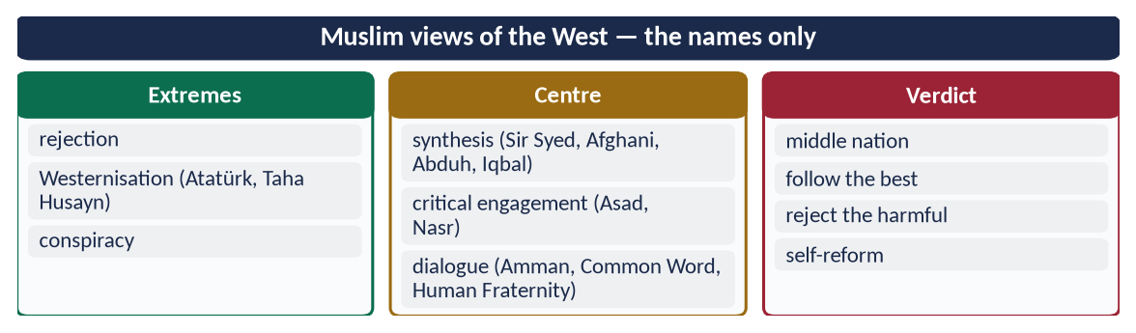
Figure 18 · At a glance — muslim views of the West — the names only. The detail is in the sections above.

(11) Conclusion
Muslim circles hold six broad views of the West. Analysis shows that both extremes — rejection and imitation — have failed, and that the conspiracy view paralyses. The synthesis, sharpened by critical engagement and practised through dialogue, is the view most faithful to the Quran's 'middle nation' and most useful for Muslim revival.

Why this answer scores
- It identifies six views with named advocates and dates.
- Each is analysed (strength and weakness), then compared in a table — the second limb fully answered.
- It ends with a reasoned verdict grounded in the Quran.

Answer 8 · The Two-Nation Theory: Justification and Demands, in the Light of Indian and Kashmiri Muslims (CSS 2026)
THE QUESTION · CSS 2026 · Q3 · 20 marks
In the light of the plight of Indian and Kashmiri Muslims, discuss the justification and demands of the Two-Nation Theory.

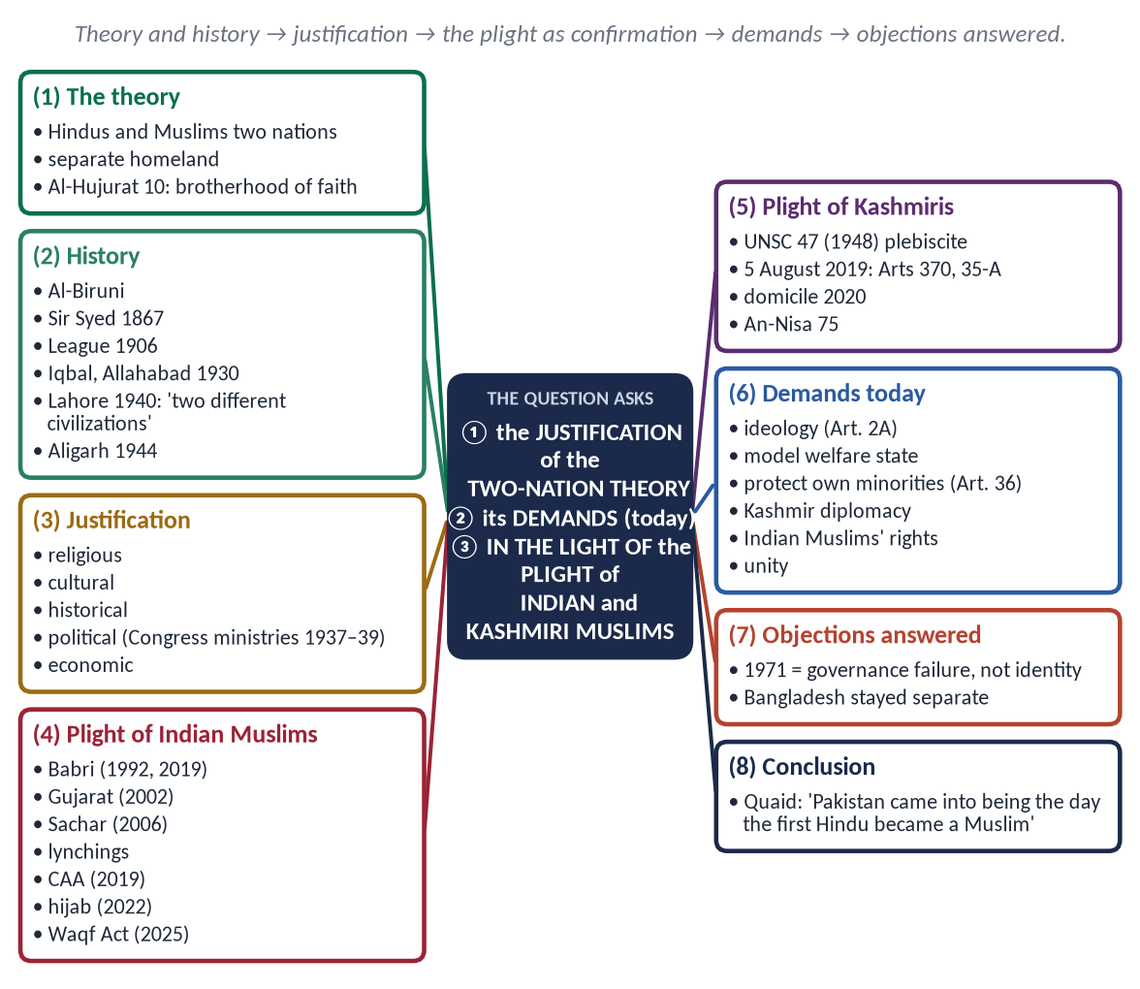
Figure 19 · The answer map: every branch is one numbered heading of the model answer below.

Decoding the question
- 'Justification' — why the theory was right: its basis and history.
- 'Demands' — what the theory requires of Pakistan and Muslims today.
- 'In the light of the plight' — use the condition of Indian and Kashmiri Muslims as evidence — factually.

The model answer

(1) Introduction
The Two-Nation Theory — Du-Qaumi Nazariyah — held that the Muslims and Hindus of the subcontinent were two separate nations, different in religion, culture, law and history, and that the Muslims needed a separate homeland to live by Islam. It was the ideological basis of Pakistan. Seventy-eight years later, the condition of India's Muslims and of Kashmir has become the strongest proof of its truth.

(2) The Islamic basis
✦ QURAN
﴿إِنَّمَا ٱلۡمُؤۡمِنُونَ إِخۡوَةٞ فَأَصۡلِحُواْ بَيۡنَ أَخَوَيۡكُمۡۚ وَٱتَّقُواْ ٱللَّهَ لَعَلَّكُمۡ تُرۡحَمُونَ﴾
“The believers are but brothers, so make settlement between your brothers. And fear Allah that you may receive mercy.” (Al-Hujurat, Quran)
➜ 'The believers are but brothers' — Muslim nationhood rests on faith, not territory.

✦ QURAN
﴿إِنَّ هَٰذِهِۦٓ أُمَّتُكُمۡ أُمَّةٗ وَٰحِدَةٗ وَأَنَا۠ رَبُّكُمۡ فَٱعۡبُدُونِ﴾
“Indeed this, your religion, is one religion, and I am your Lord, so worship Me.” (Al-Anbiya, Quran)
➜ 'This Ummah of yours is one Ummah.'

Islam is a complete way of life — law, family, economy and culture — which needs a state where Muslims can practise it fully.

(3) The historical development
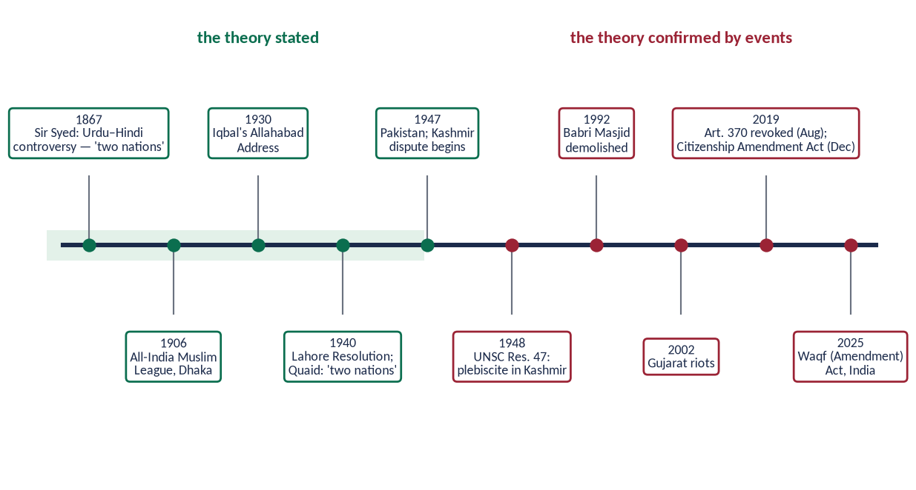
Figure 20 · The Two-Nation Theory — stated and confirmed.
- Al-Biruni (Kitab al-Hind, c. 1030) noted that Hindus and Muslims differed in religion, customs and manners.
- Sir Syed Ahmad Khan — after the Urdu–Hindi controversy (1867), he spoke of Hindus and Muslims as two nations.
- All-India Muslim League (1906); separate electorates (1909).
- Allama Iqbal, Allahabad (1930) — a consolidated North-West Indian Muslim state.
✦ SCHOLARLY VIEW
Quaid-e-Azam Muhammad Ali Jinnah · Presidential Address, Lahore, 22 March 1940
“The Hindus and Muslims belong to two different religious philosophies, social customs, literatures. They neither intermarry nor interdine together and, indeed, they belong to two different civilizations which are based mainly on conflicting ideas and conceptions.”

(4) The justification
- Religious — Islam is a complete system; Muslims need a state to live by it.
- Cultural — separate language, dress, food, festivals, calendar and heroes.
- Historical — a thousand years of separate identity.
- Political — under a permanent majority, Muslims would remain a permanent minority; the Congress ministries (1937–39) showed this, and Muslims observed the 'Day of Deliverance' when they resigned (22 December 1939).
- Economic — Muslims were behind in education, jobs and trade.

(5) The plight of Indian Muslims — the theory confirmed
India has about 200 million Muslims (14.2 percent, Census 2011). Despite constitutional secularism:
Year | Event
1992 | Babri Masjid demolished; the Supreme Court (2019) gave the site for a temple
2002 | Gujarat riots — over 1,000 killed, most of them Muslims (official figures)
2006 | Sachar Committee — Muslims behind in education, jobs and representation
2015 onwards | Lynchings over cow-protection allegations
2019 | Citizenship Amendment Act — citizenship fast-tracked for non-Muslim migrants only
2022 | Hijab ban in Karnataka's schools
2022 onwards | 'Bulldozer' demolitions of Muslim homes and shops
2025 | Waqf (Amendment) Act — opposed by Muslim organisations

The fears of 1940 — that a Muslim minority would be marginalised under a permanent majority — have been confirmed.

(6) The plight of Kashmiri Muslims
- 1947 — accession against the will of the Muslim-majority population.
- UN Security Council Resolution 47 (1948) — a free and impartial plebiscite, never held.
- 1989 onwards — heavy militarisation; UN OHCHR reports (2018, 2019) documented serious abuses.
- 5 August 2019 — India revoked Articles 370 and 35-A; a long blackout and mass detentions followed.
- 2020 — new domicile rules raised fears of demographic change.
✦ QURAN
﴿وَمَا لَكُمۡ لَا تُقَٰتِلُونَ فِي سَبِيلِ ٱللَّهِ وَٱلۡمُسۡتَضۡعَفِينَ مِنَ ٱلرِّجَالِ وَٱلنِّسَآءِ وَٱلۡوِلۡدَٰنِ …﴾
“What is wrong with you that you do not fight in the cause of Allah and for the oppressed among men, women and children?” (An-Nisa, Quran)
➜ What is wrong with you that you do not act for the oppressed men, women and children?

✦ QURAN
﴿… وَإِنِ ٱسۡتَنصَرُوكُمۡ فِي ٱلدِّينِ فَعَلَيۡكُمُ ٱلنَّصۡرُ …﴾
“And if they seek your help in the matter of religion, then it is your duty to help them.” (Al-Anfal, Quran)
➜ 'If they seek your help in the matter of religion, it is your duty to help them.'

(7) The demands of the Two-Nation Theory today
- (a) Protect Pakistan's ideology — the Objectives Resolution (Article 2A).
- (b) Make Pakistan a model — justice, rule of law and prosperity; the best argument for the theory is a successful Pakistan.
- (c) Protect Pakistan's own minorities — Article 36 and the Quaid's 11 August 1947 promise — so that the theory stands for justice, not majoritarianism.
- (d) Support the Kashmiris — diplomatically and morally, through the UN resolutions and the OIC.
- (e) Raise the rights of Indian Muslims — through diplomacy and human-rights forums, respecting international law.
- (f) National unity — provinces and communities bound by Islam and equal rights.

(8) The objections answered
- '1971 disproved the theory.' — It was a failure of governance, justice and democracy, not of Muslim identity; Bangladesh became a separate Muslim-majority state, not part of India.
- 'The 11 August speech contradicts it.' — No: the theory created the state; the speech set how the state would treat its citizens. Justice to minorities is itself Islamic (the Charter of Madinah).

(8a) Pakistan's diplomatic record on Kashmir
Pakistan has raised Kashmir at the UN Security Council (including sessions after August 2019), in the UN Human Rights Council, and through the OIC Contact Group on Jammu and Kashmir; it supports the Kashmiris' right of self-determination under the UN resolutions. The Quran's rule for such a cause is justice and steadfastness, not hatred:
✦ QURAN
﴿… وَلَا يَجۡرِمَنَّكُمۡ شَنَـَٔانُ قَوۡمٍ عَلَىٰٓ أَلَّا تَعۡدِلُواْۚ ٱعۡدِلُواْ هُوَ أَقۡرَبُ لِلتَّقۡوَىٰۖ …﴾
“Do not let the hatred of a people lead you to be unjust. Be just; that is nearer to righteousness.” (Al-Ma'idah, Quran)
➜ Do not let the hatred of a people lead you to injustice — be just; that is nearer to taqwa.

(8b) What the leaders said about the ideology of Pakistan
- Quaid, Karachi (25 January 1948): Islamic principles are 'as applicable to life today as they were 1,300 years ago'.
- Liaquat Ali Khan (1949), moving the Objectives Resolution: Pakistan was founded so that Muslims could order their lives according to Islam.
- Iqbal (1930): Islam as a 'people-building force' that had given the Muslims of India a separate identity.
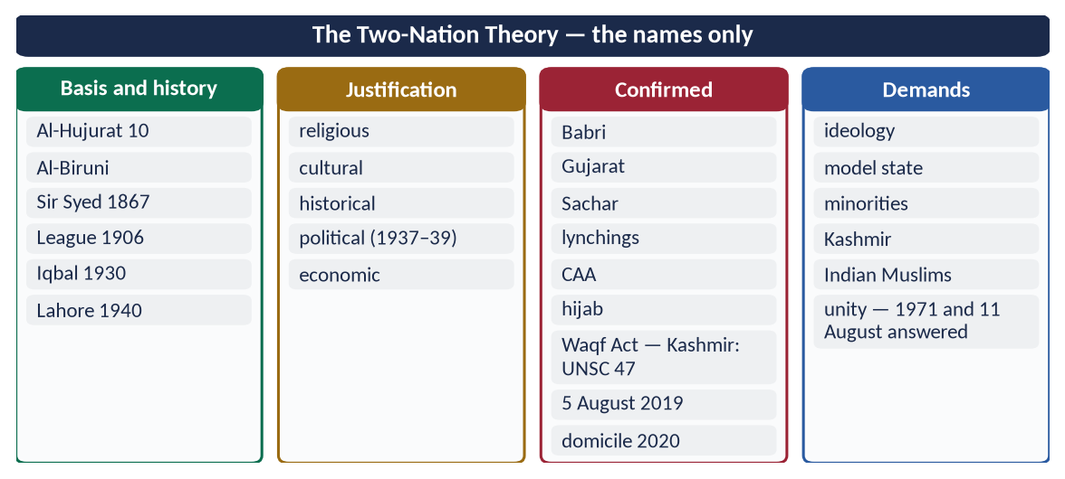
Figure 21 · At a glance — the Two-Nation Theory — the names only. The detail is in the sections above.

(9) Conclusion
✦ SCHOLARLY VIEW
Quaid-e-Azam Muhammad Ali Jinnah · Aligarh, 8 March 1944
Pakistan came into being the day the first Hindu became a Muslim in India.
➜ Nationhood rests on faith.

The plight of Indian and Kashmiri Muslims confirms the justification of the Two-Nation Theory. Its demands today are not hatred but responsibility: to make Pakistan a just, prosperous Islamic state, to protect its own minorities, and to stand by the Kashmiris and India's Muslims through law and diplomacy.

Why this answer scores
- Justification and demands in separate headings; the plight used as evidence.
- Facts are stated with dates and sources — no abusive language.
- Objections (1971, 11 August) are answered, showing depth.

Answer 9 · The West's Influence on Islamic Civilization and Measures to Protect Muslim Societies (CSS 2026)
THE QUESTION · CSS 2026 · Q4 · 20 marks
Explain how Western civilization has influenced Islamic civilization. Discuss the measures to protect Muslim societies from the negative impacts of Western culture.

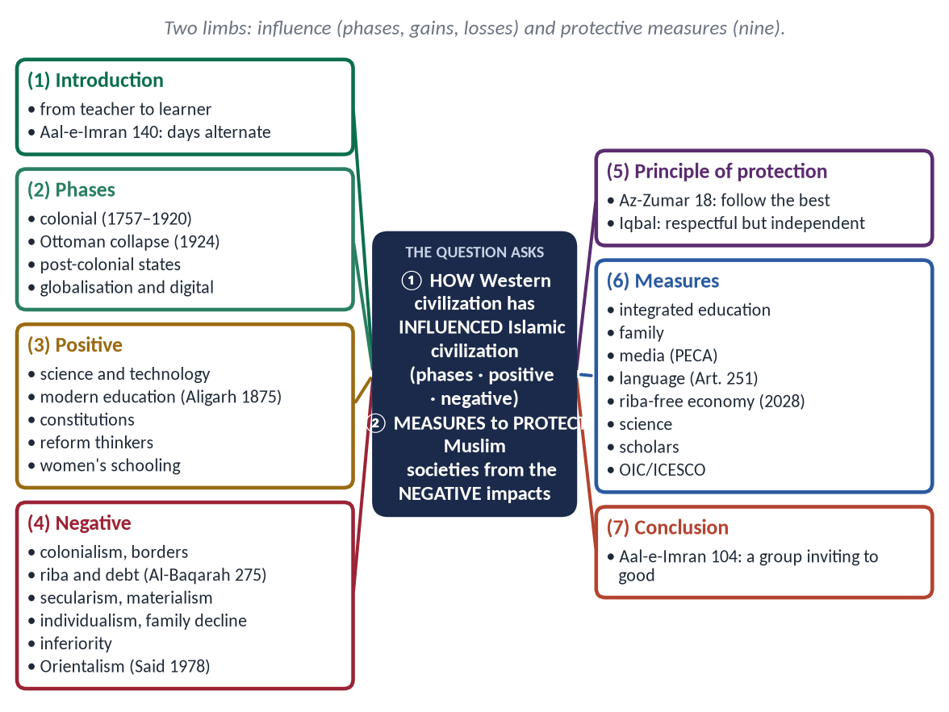
Figure 22 · The answer map: every branch is one numbered heading of the model answer below.

Decoding the question
- Limb 1 — 'how … has influenced' — explain the process (phases) and the effects (positive and negative); a one-sided answer loses marks.
- Limb 2 — 'measures to protect … from the negative impacts' — practical steps at several levels, with Islamic grounding.

The model answer

(1) Introduction
For eight centuries Islamic civilization taught Europe; from the 16th century the roles reversed. Europe's scientific, industrial and colonial power made the West dominant, and the Muslim world came under its influence.
✦ QURAN
﴿إِن يَمۡسَسۡكُمۡ قَرۡحٞ فَقَدۡ مَسَّ ٱلۡقَوۡمَ قَرۡحٞ مِّثۡلُهُۥۚ وَتِلۡكَ ٱلۡأَيَّامُ نُدَاوِلُهَا بَيۡنَ ٱلنَّاسِ وَلِيَعۡلَمَ ٱللَّهُ ٱلَّذِينَ ءَامَنُواْ وَيَتَّخِذَ مِنكُمۡ شُهَدَآءَۗ وَٱللَّهُ لَا يُحِبُّ ٱلظَّـٰلِمِينَ﴾
“If a wound should touch you - there has already touched the [opposing] people a wound similar to it. And these days [of varying conditions] We alternate among the people so that Allah may make evident those who believe and [may] take to Himself from among you martyrs - and Allah does not like the wrongdoers.” (Aal-e-Imran, Quran)
➜ 'These days (of fortune) We alternate among the people.'

(2) How the West influenced Islamic civilization — the phases
Phase | Period | Key events
Colonial conquest | 1757–1920 | Plassey (1757); Egypt (1798); Algeria (1830); 1857; Egypt (1882)
Ottoman collapse | 1914–1924 | Sykes–Picot (1916); Balfour (1917); Caliphate abolished (1924)
Post-colonial states | 1945–1990 | Western constitutions, armies, bureaucracies; Cold War
Globalisation and digital | 1990 onwards | IMF programmes; satellite TV; internet; social media

(3) The positive influences
- Science and technology — medicine, engineering, communication, computing.
- Modern education — universities and laboratories; Sir Syed's Aligarh (1875) joined modern learning with Muslim identity.
- Political systems — constitutions, parliaments, written law, fundamental rights.
- Reform and awakening — Afghani, Abduh, Sir Syed and Iqbal called for revival.
- Social progress — girls' education, public health, awareness of rights.

(4) The negative influences
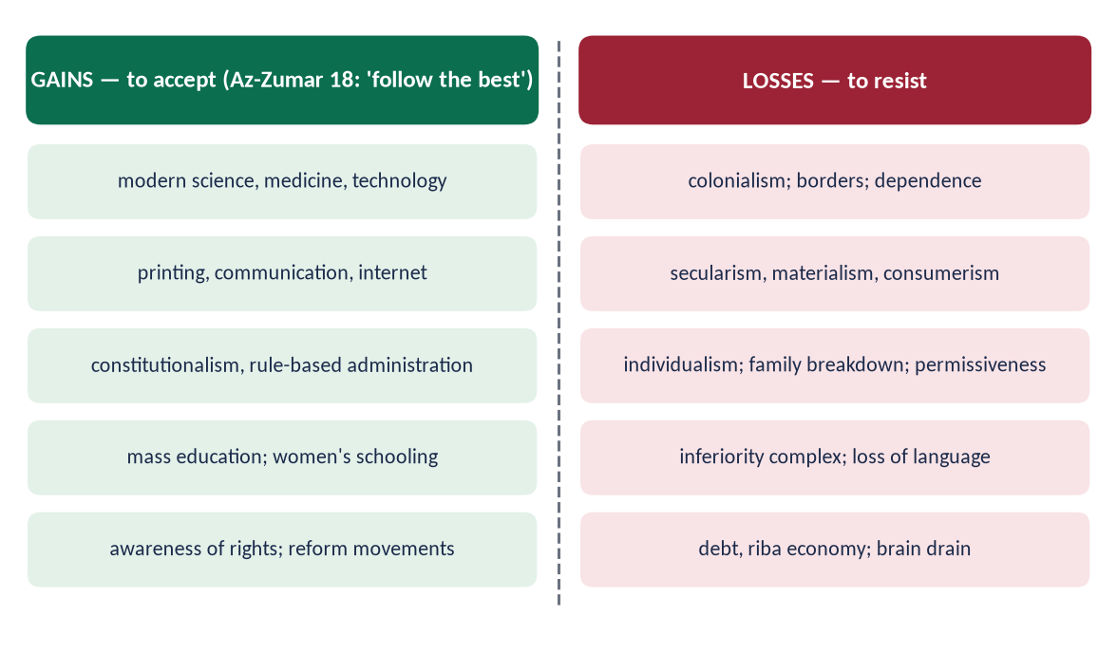
Figure 23 · The influence of the West: gains to accept and losses to resist.
- Political — colonialism; artificial borders; dependence.
- Economic — riba and debt:
✦ QURAN
﴿… وَأَحَلَّ ٱللَّهُ ٱلۡبَيۡعَ وَحَرَّمَ ٱلرِّبَوٰاْۚ …﴾
“Allah has permitted trade and forbidden riba (interest).” (Al-Baqarah, Quran)
➜ 'Allah has permitted trade and forbidden riba.'

- Ideological — secularism, materialism, moral relativism.
- Cultural — individualism, weakened family, permissiveness, consumerism, inferiority complex; English as the language of power.
- Intellectual — Orientalism:
✦ SCHOLARLY VIEW
Edward Said · Orientalism (1978)
Said showed that Western writing often cast the 'Oriental' as irrational and backward, serving colonial power.
➜ The critique of Orientalism.

- Educational — the dual system: modern schools without religion, madrasas without modern science.

(5) The measures to protect Muslim societies

(i) The principle — selective acceptance
✦ QURAN
﴿ٱلَّذِينَ يَسۡتَمِعُونَ ٱلۡقَوۡلَ فَيَتَّبِعُونَ أَحۡسَنَهُۥٓۚ أُوْلَـٰٓئِكَ ٱلَّذِينَ هَدَىٰهُمُ ٱللَّهُۖ وَأُوْلَـٰٓئِكَ هُمۡ أُوْلُواْ ٱلۡأَلۡبَٰبِ﴾
“Who listen to speech and follow the best of it. Those are the ones Allah has guided, and those are people of understanding.” (Az-Zumar, Quran)
➜ Those who listen to speech and follow the best of it — they are the ones Allah has guided.

✦ SCHOLARLY VIEW
Allama Muhammad Iqbal · Preface to The Reconstruction of Religious Thought in Islam
Approach modern knowledge with a respectful but independent attitude.
➜ Take the good, reject the harmful.

(ii) Integrated education
End the three-track system; teach Islamic history and civilization; build critical thinking; madrasas with modern subjects.

(iii) Strengthen the family
Easy marriage, time with children, respect for elders — the family is the first defence of culture.

(iv) Media and the digital space
Attractive content in Urdu and regional languages rooted in Islamic values; regulation of harmful content (PEMRA; PECA 2016); digital literacy for parents and children.

(v) Language and identity
Promote Urdu (Article 251) and regional languages; Arabic for understanding the Quran.

(vi) Economic independence
A riba-free economy — the Federal Shariat Court's judgment (2022) and the target of 1 January 2028; reduce debt; support local industry; trade among Muslim countries.

(vii) Science and technology
Invest in research and innovation — be producers, not only consumers, of technology.

(viii) Scholars and leaders
Ulema who understand the modern world; leaders who live by Islamic values; mosques as youth centres.

(ix) Cooperation among Muslim states
OIC and ICESCO programmes for culture, education and media.
✦ QURAN
﴿وَلۡتَكُن مِّنكُمۡ أُمَّةٞ يَدۡعُونَ إِلَى ٱلۡخَيۡرِ وَيَأۡمُرُونَ بِٱلۡمَعۡرُوفِ وَيَنۡهَوۡنَ عَنِ ٱلۡمُنكَرِۚ وَأُوْلَـٰٓئِكَ هُمُ ٱلۡمُفۡلِحُونَ﴾
“And let there be [arising] from you a nation inviting to [all that is] good, enjoining what is right and forbidding what is wrong, and those will be the successful.” (Aal-e-Imran, Quran)
➜ 'Let there be among you a group inviting to good, enjoining right and forbidding wrong.'

(5a) The historical Muslim responses
Response | Date | What it did
Deoband (Dar al-Ulum) | 1866 | Preserved religious learning after 1857
Aligarh (M.A.O. College) | 1875 | Modern education with Muslim identity
Anjuman-e-Himayat-e-Islam | 1884 | Schools and colleges in Lahore
Nadwat al-Ulama | 1894 | A bridge: religious learning with modern subjects
Muhammad Abduh's reforms | 1890s | Modern subjects at Al-Azhar

Each was a partial answer; together they show the path — faith preserved and knowledge embraced.

(5b) Western influence in Pakistan — examples
- Education: elite English-medium schools with foreign curricula beside weak government schools and madrasas.
- Media and lifestyle: foreign entertainment; brand culture; lavish weddings.
- Economy: IMF programmes; interest-based banking — though Islamic banking now holds about a fifth of the sector's assets.
- Values: growing individualism and delayed marriage — alongside greater awareness of rights and girls' education.
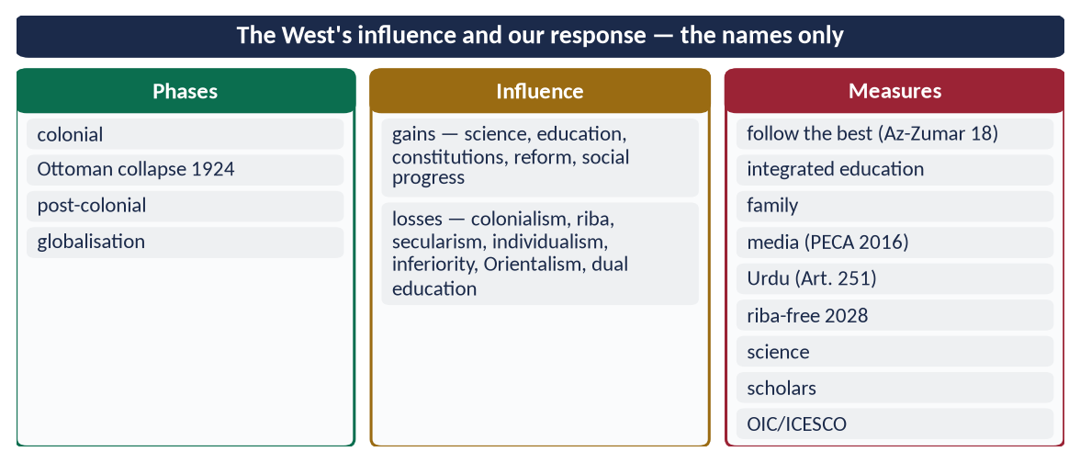
Figure 24 · At a glance — the West's influence and our response — the names only. The detail is in the sections above.

(6) Conclusion
Western civilization has shaped the Muslim world profoundly — giving it modern science and institutions while weakening its faith, family and economy. The answer is neither rejection nor imitation but selective, confident engagement: take the best, reject the harmful, and rebuild Muslim societies on their own foundations so that they can once again give, and not only receive.

Why this answer scores
- Limb 1 covers the process (phases) and both sides of the effects.
- Limb 2 gives nine practical measures with Islamic grounding and Pakistani references.
- A figure and a phases table make the answer quick to mark.

